





(Affiliated to Central Board of Secondary Education, New Delhi)

(Chettinad House, R.A.Puram, Chennai – 600 028)

# COMPUTER SCIENCE

Certified to be the Bonafide Record of work done by

________________________________________ of Std XII Sec ____

in the Computer Science Lab of the CHETTINAD VIDYASHRAM,

CHENNAI, during the year 2021 – 2022.

Date: Teacher-in-charge

## REGISTER NO. ___________________

#### Submitted for All India Senior Secondary Practical Examination in

#### Computer Science held on ______________________________at

#### Chettinad Vidyashram, Chennai – 600 028.

#### Principal Internal Examiner External Examiner

**ACKNOWLEDGEMENT**

I would like to express my sincere thanks to

Meena Aunty, Principal Mrs. S.Amudha lakshmi

for their encouragement and support to work on

this Project. I am grateful to my computer science

teacher UMA MAGESWARI R and to the computer science department for the constant guidance and support to complete the project

***TABLE OF CONTENT***

|  |  |  |
| --- | --- | --- |
| S.No | Index | Page No |
| 1. | Overview of Python | 5 |
| 2. | Project Description | 6 |
| 3. | Functions Used | 8 |
| 4. | Tables used | 10 |
| 5. | Source Code | 23 |
| 6. | Sample Output | 79 |
| 7. | Conclusion | 92 |
| 8. | Bibiliography | 93 |

**OVERVIEW OF PYTHON**

Python is a **computer programming language often used to build websites and software, automate tasks, and conduct data analysis**. Python is a general-purpose language, meaning it can be used to create a variety of different programs and isn't specialized for any specific problems.

It is a high-level, **interpreted, interactive and object-oriented scripting** language. Python is designed to be highly readable. It uses English keywords frequently where as other languages use punctuation, and it has fewer syntactical constructions than other languages.

1. **Python is Interpreted** − Python is processed at runtime by the interpreter. You do not need to compile your program before executing it. This is similar to PERL and PHP.
2. **Python is Interactive** − You can actually sit at a Python prompt and interact with the interpreter directly to write your programs.
3. **Python is Object-Oriented** − Python supports Object-Oriented style or technique of programming that encapsulates code within objects.
4. **Python is a Beginner's Language** − Python is a great language for the beginner-level programmers and supports the development of a wide range of applications from simple text processing to WWW browsers to games.

Python's features include −

* **Easy-to-learn** − Python has few keywords, simple structure, and a clearly defined syntax. This allows the student to pick up the language quickly.
* **Easy-to-read** − Python code is more clearly defined and visible to the eyes.
* **Easy-to-maintain** − Python's source code is fairly easy-to-maintain.
* **A broad standard library** − Python's bulk of the library is very portable and cross-platform compatible on UNIX, Windows, and Macintosh.
* **Interactive Mode** − Python has support for an interactive mode which allows interactive testing and debugging of snippets of code.
* **Portable** − Python can run on a wide variety of hardware platforms and has the same interface on all platforms.
* **Databases** − Python provides interfaces to all major commercial databases.
* **GUI Programming** − Python supports GUI applications that can be created and ported to many system calls, libraries and windows systems, such as Windows MFC, Macintosh, and the X Window system of Unix.
* **Scalable** − Python provides a better structure and support for large programs than shell scripting.

**PROJECT DESCRIPTION**

Our project titled “CVTERIA” provides a GUI based system to efficiently manage a cafeteria. We have used a combination of Python and MySQL for the back-end code and have designed a simple yet robust front-end GUI using Tkinter.

This application allows both the staff at a cafeteria and the cafeteria manager to manage records of the customers digitally. It includes features like adding customers, updating customer details, deleting customer details, and ability to view the list of customers including different sorting capabilities. For security purposes we have built a simple yet powerful password validation function. Our appropriate pop-up messages for various scenarios helps the user understand what he or she has done to the database.

The application has multiple validations at user enterable fields and data base level exceptions. We have mapped all the errors with user friendly messages.

The system runs without any glitches at an optimal speed. Being an open-source application, this is a cost-effective solution for small cafeterias.

**FUNCTIONS USED**

|  |  |  |  |
| --- | --- | --- | --- |
| Functions Used | | Function Description | |
| connect() | | Used to connect mysql to python | |
| setup() | | To create tables and declare variables | |
| seed() | | To create data inside each table, like menu etc. | |
| customer_create() | | To create customer | |
| customer_update() | | To update customer | |
| customer_delete() | | To delete customer | |
| bill_delete() | | To delete bill | |
| order_delete() | | To delete an order | |
| customer_get_all() | | To fetch all customers from database | |
| customer_get_by_id() | To get customer information for a given customer ID | |
| order_header_create() | To create order header | |
| order_header_update() | To update order header | |
| order_detail_update() | To update order details | |
| order_detail_create() | To create order details | |
| order_header_get_all() | To fetch all order headers from the database | |
| order_header_get_upaid() | To get order header on paying the bill | |
| order_header_get_by_id() | To get order header by order ID | |
| order_detail_get_all() | To fetch all order details from the database | |
| order_detail_get_by_id() | To get order details by order ID. | |

|  |  |
| --- | --- |
| order_detail_delete_by_id() | To delete order details based on given order ID. |
| item_get_all() | To Get all menu items from the database |
| item_get_by_category_id() | To get all menu items from the database based on category ID. |
| table_get_all() | To get all tables from the database |
| table_reservation_get_all() | To get all table reservations from the database |
| table_reservation_get_by_id() | To get table reservations from the database based on ID |
| table_reservation_create() | To create a new table reservation |
| table_reservation_update() | To update table reservation details |
| table_reservation_delete() | To delete table reservations |
| payment_mode_get_all() | To get all payment modes from the database. |

|  |  |
| --- | --- |
| bill_create() | To create a new bill. |
| bill_update() | To update bill details. |
| Bill_get_all() | To get all bills from the database |
| bill_get_by_id() | To get all bills from the database based on ID. |
| bill_get_buy_order_header_id() | To get all bills from database based on order header ID |
| bill_get_buy_customer_id() | To get all bills from database based on customer ID |
| category_get_all() | To get all categories from the database |

**TABLES USED**

**BILL**

Description:

The bill table is used to store the details of every bill. It has attributes like bill_id, discount,final_amount,payment_mode_id,date_time etc. This table can be accessed only by the owner of the café in order to manage the cafeteria.

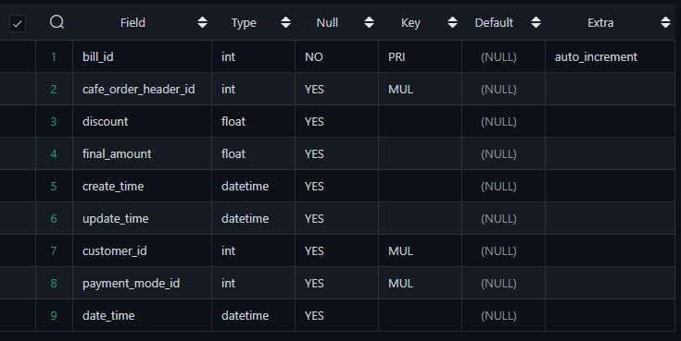Structure:

**Café_order_detail**

Description:

The table contains the details of every order that has been placed at our café. It has attributes like cafe_order_detail_id, menu_id, qty, unit_price etc.

Structure: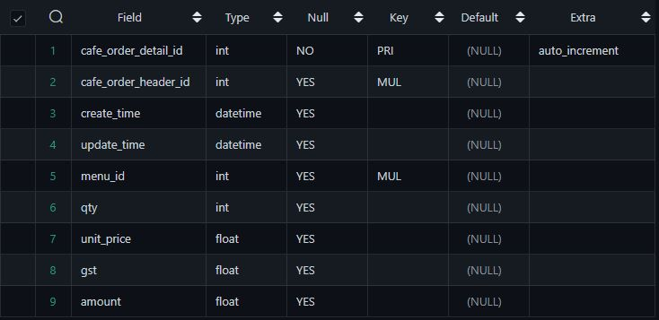

**Cafe_order_header**

Description:

This table stores details of order headers and total amount of each order. It has attributes like café_table_id, total_amount etc.

Structure: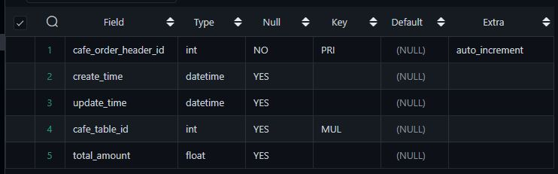

**Cafe_table**

Description:

This table is used to store the details of the tables at our café. It has attributes like café_table_id,café_table_number etc.

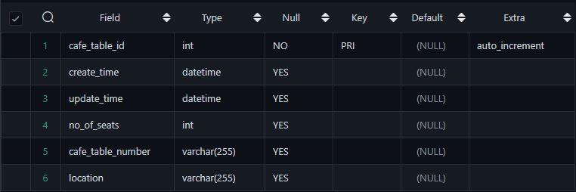Structure:

**Category**

Description:

This table stores the categories to which each menu item belongs to. It has attributes like category_id, category_name etc.

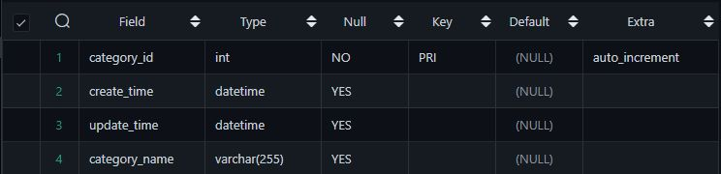Structure:

**Customer**

Description:

This table is used to store the details of the customers who have created accounts at our café.It has attrbutes like customer_id,customer_name etc.

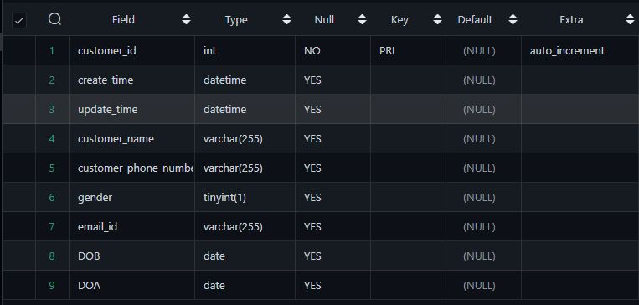Structure:

**Menu**

Description:

This table stores all our menu items. It has attributes like menu_id, price,item etc.

Structure:

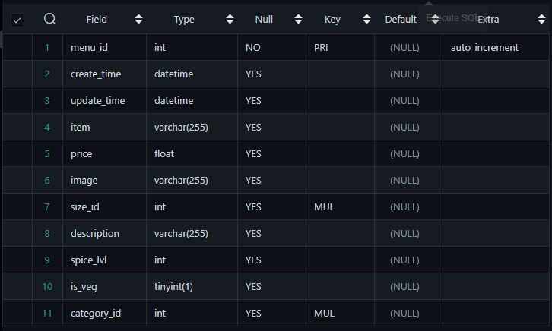

**Payment mode**

Description:

This table stores the different payment modes our café offers. It has attributes like payment_mode_id, payment_mode_name etc.

Structure:

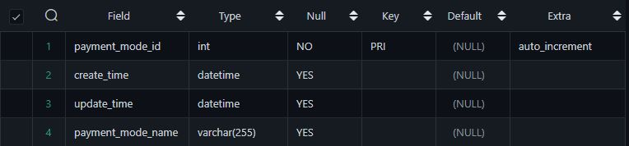

**Reservation**

Description:

This table stores all the reservations made by customers at our café. It has attributes like reservation_id, no_of_seats etc.

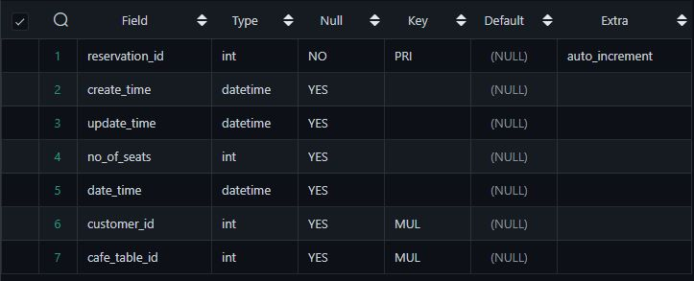Structure:

**Size**

Description:This tables stores the different sizes that our café offers for each item. It has attributes like size_id, size_name..

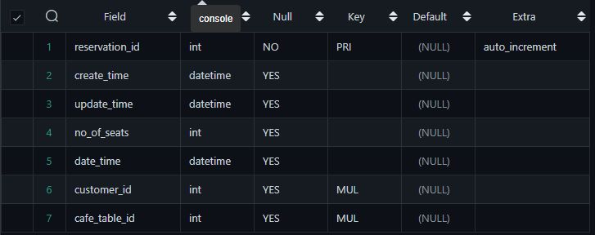Structure:

**db.py**

import mysql.connector as bot

from model.category import Category

from model.customer import Customer

from model.order_header import OrderHeader

from model.order_detail import OrderDetail

from model.item import Item

from model.table import Table

from model.table_reservation import TableReservation

from model.payment_mode import PaymentMode

from model.bill import Bill

mydb = None

class Database():

def connect(self):

mydb = bot.connect(

host = 'localhost',

user = 'root',

password = 'Tiger@123',

database = 'cvteria'

)

if mydb:

print('connected to the db successfully!!')

else:

print('could not connect to DB')

return mydb

def setup(self):

#CREATE DATBASE

con = bot.connect(host="localhost",user="root",password="Tiger@123",charset='utf8')

cur = con.cursor()

cur.execute("""

CREATE DATABASE IF NOT EXISTS cvteria

""")

mydb = self.connect()

mycursor = mydb.cursor()

#CREATE TABLES

#size

mycursor.execute("""

CREATE TABLE IF NOT EXISTS

size(

size_id int NOT NULL PRIMARY KEY AUTO_INCREMENT COMMENT 'Primary Key',

create_time DATETIME COMMENT 'Create Time',

update_time DATETIME COMMENT 'Update Time',

size_name VARCHAR(255)

);

""")

#category

mycursor.execute("""

CREATE TABLE IF NOT EXISTS

category(

category_id int NOT NULL PRIMARY KEY AUTO_INCREMENT COMMENT 'Primary Key',

create_time DATETIME COMMENT 'Create Time',

update_time DATETIME COMMENT 'Update Time',

category_name VARCHAR(255)

);

""")

#payment_mode

mycursor.execute("""

CREATE TABLE IF NOT EXISTS

payment_mode(

payment_mode_id int NOT NULL PRIMARY KEY AUTO_INCREMENT COMMENT 'Primary Key',

create_time DATETIME COMMENT 'Create Time',

update_time DATETIME COMMENT 'Update Time',

payment_mode_name VARCHAR(255)

);

""")

#menu

mycursor.execute("""

CREATE TABLE IF NOT EXISTS

menu(

menu_id int NOT NULL PRIMARY KEY AUTO_INCREMENT COMMENT 'Primary Key',

create_time DATETIME COMMENT 'Create Time',

update_time DATETIME COMMENT 'Update Time',

item VARCHAR(255),

price FLOAT,

image VARCHAR(255),

size_id INT, INDEX size_id (size_id),CONSTRAINT fk_size_id FOREIGN KEY (size_id) REFERENCES size(size_id) ,

description VARCHAR(255),

spice_lvl INT,

is_veg BOOLEAN,

category_id INT, INDEX category_id (category_id),CONSTRAINT fk_category_id FOREIGN KEY (category_id) REFERENCES category(category_id)

);

""")

#cafe_table

mycursor.execute("""

CREATE TABLE IF NOT EXISTS

cafe_table(

cafe_table_id int NOT NULL PRIMARY KEY AUTO_INCREMENT COMMENT 'Primary Key',

create_time DATETIME COMMENT 'Create Time',

update_time DATETIME COMMENT 'Update Time',

no_of_seats INT,

cafe_table_number VARCHAR(255),

location VARCHAR(255)

);

""")

#customer

mycursor.execute("""

CREATE TABLE IF NOT EXISTS

customer(

customer_id int NOT NULL PRIMARY KEY AUTO_INCREMENT COMMENT 'Primary Key',

create_time DATETIME COMMENT 'Create Time',

update_time DATETIME COMMENT 'Update Time',

customer_name VARCHAR(255),

customer_phone_number VARCHAR(255),

gender BOOLEAN,

email_id VARCHAR(255),

DOB DATE,

DOA DATE

);

""")

#reservation

mycursor.execute("""

CREATE TABLE IF NOT EXISTS

reservation(

reservation_id int NOT NULL PRIMARY KEY AUTO_INCREMENT COMMENT 'Primary Key',

create_time DATETIME COMMENT 'Create Time',

update_time DATETIME COMMENT 'Update Time',

no_of_seats INT,

date_time DATETIME,

customer_id INT, INDEX customer_id (customer_id),CONSTRAINT fk_customer_id FOREIGN KEY (customer_id) REFERENCES customer(customer_id) ,

cafe_table_id INT, INDEX cafe_table_id (cafe_table_id),CONSTRAINT fk_cafe_table_id FOREIGN KEY (cafe_table_id) REFERENCES cafe_table(cafe_table_id)

);

""")

#cafe_order_header

mycursor.execute("""

CREATE TABLE IF NOT EXISTS

cafe_order_header(

cafe_order_header_id int NOT NULL PRIMARY KEY AUTO_INCREMENT COMMENT 'Primary Key',

create_time DATETIME COMMENT 'Create Time',

update_time DATETIME COMMENT 'Update Time',

cafe_table_id INT, INDEX cafe_table_id(cafe_table_id),CONSTRAINT fk_cafe_order_header_cafe_table_id FOREIGN KEY (cafe_table_id) REFERENCES cafe_table(cafe_table_id) ,

total_amount FLOAT

);

""")

#cafe_order_detail

mycursor.execute("""

CREATE TABLE IF NOT EXISTS

cafe_order_detail(

cafe_order_detail_id int NOT NULL PRIMARY KEY AUTO_INCREMENT COMMENT 'Primary Key',

cafe_order_header_id INT, INDEX cafe_order_header_id(cafe_order_header_id),CONSTRAINT fk_cafe_order_header_id FOREIGN KEY (cafe_order_header_id) REFERENCES cafe_order_header(cafe_order_header_id) ,

create_time DATETIME COMMENT 'Create Time',

update_time DATETIME COMMENT 'Update Time',

menu_id INT, INDEX menu_id(menu_id),CONSTRAINT fk_cafe_order_detail_menu_id FOREIGN KEY (menu_id) REFERENCES menu(menu_id) ,

qty INT,

unit_price float,

gst float,

amount FLOAT

);

""")

#bill

mycursor.execute("""

CREATE TABLE IF NOT EXISTS

bill(

bill_id int NOT NULL PRIMARY KEY AUTO_INCREMENT COMMENT 'Primary Key',

cafe_order_header_id INT, INDEX cafe_order_header_id(cafe_order_header_id),CONSTRAINT fk_cafe_order_header_id_bill FOREIGN KEY (cafe_order_header_id) REFERENCES cafe_order_header(cafe_order_header_id) ,

discount float,

final_amount float,

create_time DATETIME COMMENT 'Create Time',

update_time DATETIME COMMENT 'Update Time',

customer_id INT, INDEX customer_id (customer_id),CONSTRAINT fk_bill_customer_id FOREIGN KEY (customer_id) REFERENCES customer(customer_id) ,

payment_mode_id INT, INDEX payment_mode_id (payment_mode_id),CONSTRAINT fk_payment_mode_id FOREIGN KEY (payment_mode_id) REFERENCES payment_mode(payment_mode_id) ,

date_time DATETIME

);

""")

mydb.commit()

def seed(self):

mydb = self.connect()

mycursor = mydb.cursor()

#INSERT DEFAULT RECORDS

#size

mycursor.execute("insert into size(size_name,create_time,update_time) VALUES('Demi',now(),now());")

mycursor.execute("insert into size(size_name,create_time,update_time) VALUES('Short',now(),now());")

mycursor.execute("insert into size(size_name,create_time,update_time) VALUES('Tall',now(),now());")

mycursor.execute("insert into size(size_name,create_time,update_time) VALUES('Venti',now(),now());")

mycursor.execute("insert into size(size_name,create_time,update_time) VALUES('Grande',now(),now());")

mycursor.execute("insert into size(size_name,create_time,update_time) VALUES('Trenta',now(),now());")

mydb.commit()

#category

mycursor.execute("insert into category(category_name,create_time,update_time) VALUES('Hot Beverages',now(),now());")

mycursor.execute("insert into category(category_name,create_time,update_time) VALUES('Cold Beverages',now(),now());")

mycursor.execute("insert into category(category_name,create_time,update_time) VALUES('Quick Bites',now(),now());")

mycursor.execute("insert into category(category_name,create_time,update_time) VALUES('Sandwiches',now(),now());")

mycursor.execute("insert into category(category_name,create_time,update_time) VALUES('Desserts',now(),now());")

mycursor.execute("insert into category(category_name,create_time,update_time) VALUES('Donuts',now(),now());")

mycursor.execute("insert into category(category_name,create_time,update_time) VALUES('English Breakfast',now(),now());")

mycursor.execute("insert into category(category_name,create_time,update_time) VALUES('Soups',now(),now());")

mycursor.execute("insert into category(category_name,create_time,update_time) VALUES('Grab-n-Go',now(),now());")

mydb.commit()

#payment_mode

mycursor.execute("insert into payment_mode(payment_mode_name,create_time,update_time) VALUES('Cash',now(),now());")

mycursor.execute("insert into payment_mode(payment_mode_name,create_time,update_time) VALUES('Card',now(),now());")

mycursor.execute("insert into payment_mode(payment_mode_name,create_time,update_time) VALUES('UPI',now(),now());")

mydb.commit()

#menu

mycursor.execute("insert into menu(item, price, size_id, description, spice_lvl, is_veg, category_id, create_time,update_time) VALUES('Cappucino', 399, null, null, 0, True, 1, now(),now());")

mycursor.execute("insert into menu(item, price, size_id, description, spice_lvl, is_veg, category_id, create_time,update_time) VALUES('Yamamoto Tea', 299, null, null, 0, True, 1, now(),now());")

mycursor.execute("insert into menu(item, price, size_id, description, spice_lvl, is_veg, category_id, create_time,update_time) VALUES('Miguel Drink', 249, null, null, 0, True, 1, now(),now());")

mycursor.execute("insert into menu(item, price, size_id, description, spice_lvl, is_veg, category_id, create_time,update_time) VALUES('Hot Chocolate', 349, null, null, 0, True, 1, now(),now());")

mycursor.execute("insert into menu(item, price, size_id, description, spice_lvl, is_veg, category_id, create_time,update_time) VALUES('Frappe', 399, null, null, 0, True, 2, now(),now());")

mycursor.execute("insert into menu(item, price, size_id, description, spice_lvl, is_veg, category_id, create_time,update_time) VALUES('Iced Tea', 299, null, null, 0, True, 2, now(),now());")

mycursor.execute("insert into menu(item, price, size_id, description, spice_lvl, is_veg, category_id, create_time,update_time) VALUES('Oreo Milkshake', 249, null, null, 0, True, 2, now(),now());")

mycursor.execute("insert into menu(item, price, size_id, description, spice_lvl, is_veg, category_id, create_time,update_time) VALUES('Blue Lagoon Mojito', 199, null, null, 0, True, 2, now(),now());")

mycursor.execute("insert into menu(item, price, size_id, description, spice_lvl, is_veg, category_id, create_time,update_time) VALUES('Corn Cheese Balls', 349, null, null, 1, True, 3, now(),now());")

mycursor.execute("insert into menu(item, price, size_id, description, spice_lvl, is_veg, category_id, create_time,update_time) VALUES('Potato Wedges', 199, null, null, 1, True, 3, now(),now());")

mycursor.execute("insert into menu(item, price, size_id, description, spice_lvl, is_veg, category_id, create_time,update_time) VALUES('Peri Peri Fries', 299, null, null, 2, True, 3, now(),now());")

mycursor.execute("insert into menu(item, price, size_id, description, spice_lvl, is_veg, category_id, create_time,update_time) VALUES('Merry Mellow Chicken Bites', 249, null, null, 3, False, 3, now(),now());")

mycursor.execute("insert into menu(item, price, size_id, description, spice_lvl, is_veg, category_id, create_time,update_time) VALUES('White Italian Tomato Sandwich', 249, null, null, 1, True, 4, now(),now());")

mycursor.execute("insert into menu(item, price, size_id, description, spice_lvl, is_veg, category_id, create_time,update_time) VALUES('Mexican Grilled Cheese Sandwich', 299, null, null, 2, True, 4, now(),now());")

mycursor.execute("insert into menu(item, price, size_id, description, spice_lvl, is_veg, category_id, create_time,update_time) VALUES('Chicken Tikka Sandwich', 249, null, null, 3, False, 4, now(),now());")

mycursor.execute("insert into menu(item, price, size_id, description, spice_lvl, is_veg, category_id, create_time,update_time) VALUES('Mutton Sheekh Sandwich', 299, null, null, 3, False, 4, now(),now());")

mycursor.execute("insert into menu(item, price, size_id, description, spice_lvl, is_veg, category_id, create_time,update_time) VALUES('Tiramisu', 249, null, null, 0, True, 5, now(),now());")

mycursor.execute("insert into menu(item, price, size_id, description, spice_lvl, is_veg, category_id, create_time,update_time) VALUES('Sizzling Chocolate Brownie', 299, null, null, 0, True, 5, now(),now());")

mycursor.execute("insert into menu(item, price, size_id, description, spice_lvl, is_veg, category_id, create_time,update_time) VALUES('Cheesecake', 149, null, null, 0, True, 5, now(),now());")

mycursor.execute("insert into menu(item, price, size_id, description, spice_lvl, is_veg, category_id, create_time,update_time) VALUES('Gelato Ice Cream', 149, null, null, 0, True, 5, now(),now());")

mycursor.execute("insert into menu(item, price, size_id, description, spice_lvl, is_veg, category_id, create_time,update_time) VALUES('Oreo Cookies and Creme Donut', 149, null, null, 0, True, 6, now(),now());")

mycursor.execute("insert into menu(item, price, size_id, description, spice_lvl, is_veg, category_id, create_time,update_time) VALUES('Glazed Blueberry Donut', 249, null, null, 0, True, 6, now(),now());")

mycursor.execute("insert into menu(item, price, size_id, description, spice_lvl, is_veg, category_id, create_time,update_time) VALUES('Reeses Classic Donut', 249, null, null, 0, True, 6, now(),now());")

mycursor.execute("insert into menu(item, price, size_id, description, spice_lvl, is_veg, category_id, create_time,update_time) VALUES('Chocolate Iced Raspberry Donut', 149, null, null, 0, True, 6, now(),now());")

mycursor.execute("insert into menu(item, price, size_id, description, spice_lvl, is_veg, category_id, create_time,update_time) VALUES('Croissant', 99, null, null, 0, True, 7, now(),now());")

mycursor.execute("insert into menu(item, price, size_id, description, spice_lvl, is_veg, category_id, create_time,update_time) VALUES('Bagel', 99, null, null, 0, True, 7, now(),now());")

mycursor.execute("insert into menu(item, price, size_id, description, spice_lvl, is_veg, category_id, create_time,update_time) VALUES('Sunny side up', 149, null, null, 1, False, 7, now(),now());")

mycursor.execute("insert into menu(item, price, size_id, description, spice_lvl, is_veg, category_id, create_time,update_time) VALUES('Bacon and Mushroom Peas', 249, null, null, 1, False, 7, now(),now());")

mycursor.execute("insert into menu(item, price, size_id, description, spice_lvl, is_veg, category_id, create_time,update_time) VALUES('Hot N Sour Soup', 99, null, null, 1, True, 8, now(),now());")

mycursor.execute("insert into menu(item, price, size_id, description, spice_lvl, is_veg, category_id, create_time,update_time) VALUES('Sweet Corn Soup', 99, null, null, 1, True, 8, now(),now());")

mycursor.execute("insert into menu(item, price, size_id, description, spice_lvl, is_veg, category_id, create_time,update_time) VALUES('Cream of Mushroom Soup', 99, null, null, 0, True, 8, now(),now());")

mycursor.execute("insert into menu(item, price, size_id, description, spice_lvl, is_veg, category_id, create_time,update_time) VALUES('Clear Chicken Soup', 99, null, null, 1, False, 8, now(),now());")

mycursor.execute("insert into menu(item, price, size_id, description, spice_lvl, is_veg, category_id, create_time,update_time) VALUES('Veg Frankie', 199, null, null, 1, True, 9, now(),now());")

mycursor.execute("insert into menu(item, price, size_id, description, spice_lvl, is_veg, category_id, create_time,update_time) VALUES('Chicken Frankie', 199, null, null, 2, False, 9, now(),now());")

mycursor.execute("insert into menu(item, price, size_id, description, spice_lvl, is_veg, category_id, create_time,update_time) VALUES('Choco Chip Cookies', 99, null, null, 0, True, 9, now(),now());")

mycursor.execute("insert into menu(item, price, size_id, description, spice_lvl, is_veg, category_id, create_time,update_time) VALUES('Spicy Chips', 99, null, null, 2, True, 9, now(),now());")

mydb.commit()

#cafe_table

mycursor.execute("insert into cafe_table(cafe_table_number, no_of_seats, location, create_time,update_time) VALUES('Table 01', 2, '1st Floor, North East', now(),now());")

mycursor.execute("insert into cafe_table(cafe_table_number, no_of_seats, location, create_time,update_time) VALUES('Table 02', 4, '1st Floor, South', now(),now());")

mycursor.execute("insert into cafe_table(cafe_table_number, no_of_seats, location, create_time,update_time) VALUES('Table 03', 6, '1st Floor, Center', now(),now());")

mycursor.execute("insert into cafe_table(cafe_table_number, no_of_seats, location, create_time,update_time) VALUES('Table 04', 2, '2nd Floor, North East', now(),now());")

mycursor.execute("insert into cafe_table(cafe_table_number, no_of_seats, location, create_time,update_time) VALUES('Table 05', 4, '2nd Floor, South', now(),now());")

mycursor.execute("insert into cafe_table(cafe_table_number, no_of_seats, location, create_time,update_time) VALUES('Table 06', 6, '2nd Floor, Center', now(),now());")

mycursor.execute("insert into cafe_table(cafe_table_number, no_of_seats, location, create_time,update_time) VALUES('Table 07', 2, '3rd Floor, North East', now(),now());")

mycursor.execute("insert into cafe_table(cafe_table_number, no_of_seats, location, create_time,update_time) VALUES('Table 08', 4, '3rd Floor, South', now(),now());")

mycursor.execute("insert into cafe_table(cafe_table_number, no_of_seats, location, create_time,update_time) VALUES('Table 09', 6, '3rd Floor, Center', now(),now());")

mydb.commit()

def customer_create(self, cust=Customer):

mydb = self.connect()

mycursor = mydb.cursor()

sql = "insert into customer(customer_name,customer_phone_number, gender, email_id, DOB, DOA, create_time,update_time) VALUES (%s, %s, %s, %s, %s, %s, now(), now())"

val = (cust.customer_name, cust.phone_number, cust.gender, cust.email_id, cust.DOB, cust.anniversary_date)

mycursor.execute(sql, val)

mydb.commit()

print('customer created ')

def customer_update(self, cust=Customer):

mydb = self.connect()

mycursor = mydb.cursor()

sql = "update customer set customer_name=%s,customer_phone_number=%s, gender=%s, email_id=%s, DOB=%s, DOA=%s, update_time=now() where customer_id=%s"

val = (cust.customer_name, cust.phone_number, cust.gender, cust.email_id, cust.DOB, cust.anniversary_date, cust.customer_id)

mycursor.execute(sql, val)

mydb.commit()

print('customer updated')

def customer_delete(self, customer_id):

mydb = self.connect()

mycursor = mydb.cursor()

sql = "delete from customer where customer_id=" + str(customer_id)

mycursor.execute(sql)

mydb.commit()

print('customer updated')

def bill_delete(self, bill_id):

mydb = self.connect()

mycursor = mydb.cursor()

sql = "delete from bill where bill_id=" + str(bill_id)

mycursor.execute(sql)

mydb.commit()

print('bill updated')

def order_delete(self, cafe_order_header_id):

mydb = self.connect()

mycursor = mydb.cursor()

sql = "delete from cafe_order_detail where cafe_order_header_id=" + str(cafe_order_header_id)

mycursor.execute(sql)

sql = "delete from cafe_order_header where cafe_order_header_id=" + str(cafe_order_header_id)

mycursor.execute(sql)

mydb.commit()

print('order updated')

def customer_get_all(self):

mydb = self.connect()

mycursor = mydb.cursor()

mycursor.execute("select customer_id, customer_name,customer_phone_number, gender, email_id, DOB, DOA, create_time,update_time from customer order by customer_id desc")

list_of_customer = mycursor.fetchall()

cust_list = []

for data in list_of_customer:

cust = Customer()

cust.customer_id = data[0]

cust.customer_name = data[1]

cust.phone_number = data[2]

cust.gender = data[3]

cust.email_id = data[4]

cust.DOB = data[5]

cust.anniversary_date = data[6]

cust_list.append(cust)

print(f"|{cust.customer_id:4}")

return cust_list

def customer_get_by_id(self, customer_id):

mydb = self.connect()

mycursor = mydb.cursor()

mycursor.execute("select customer_id, customer_name,customer_phone_number, gender, email_id, DOB, DOA, create_time,update_time from customer where customer_id=" + str(customer_id))

list_of_customer = mycursor.fetchall()

cust_list = []

for data in list_of_customer:

cust = Customer()

cust.customer_id = data[0]

cust.customer_name = data[1]

cust.phone_number = data[2]

cust.gender = data[3]

cust.email_id = data[4]

cust.DOB = data[5]

cust.anniversary_date = data[6]

cust_list.append(cust)

print(f"|{cust.customer_id:4}")

return cust_list

def order_header_create(self, ord=OrderHeader):

mydb = self.connect()

mycursor = mydb.cursor()

sql = "insert into cafe_order_header(cafe_table_id, total_amount, create_time,update_time) VALUES (%s, %s, now(), now())"

val = (ord.table_id, ord.total_amount)

mycursor.execute(sql, val)

mydb.commit()

print('Order created ')

return mycursor.lastrowid

def order_header_update(self, ord=OrderHeader):

mydb = self.connect()

mycursor = mydb.cursor()

sql = "update cafe_order_header set total_amount = %s, update_time=now() where cafe_order_header_id=%s"

val = (ord.total_amount, ord.order_header_id)

mycursor.execute(sql, val)

mydb.commit()

print('Order updated')

return mycursor.lastrowid

def order_detail_update(self, ord=OrderDetail):

mydb = self.connect()

mycursor = mydb.cursor()

sql = "update cafe_order_detail set menu_id=%s, qty=%s, unit_price=%s, gst=%s, amount=%s, update_time=now() where cafe_order_detail_id = %s"

val = (ord.item_id, ord.qty, ord.price, ord.gst, ord.amount, ord.order_detail_id)

mycursor.execute(sql, val)

mydb.commit()

print('Order detail updated')

def order_detail_create(self, ord=OrderDetail):

mydb = self.connect()

mycursor = mydb.cursor()

sql = "insert into cafe_order_detail(cafe_order_header_id, menu_id, qty, unit_price, gst, amount, create_time,update_time) VALUES (%s, %s, %s, %s, %s, %s, now(), now())"

val = (ord.order_header_id, ord.item_id, ord.qty, ord.price, ord.gst, ord.amount)

mycursor.execute(sql, val)

mydb.commit()

print('Order created ')

def order_header_get_all(self):

mydb = self.connect()

mycursor = mydb.cursor()

mycursor.execute("select cafe_order_header_id, c.cafe_table_id, cafe_table_number, total_amount, c.create_time from cafe_order_header c inner join cafe_table t on c.cafe_table_id = t.cafe_table_id order by cafe_order_header_id desc")

list = mycursor.fetchall()

output_list = []

for data in list:

ord = OrderHeader()

ord.order_header_id = data[0]

ord.table_id = data[1]

ord.table_number = data[2]

ord.total_amount = data[3]

ord.create_time = data[4]

output_list.append(ord)

print(f"|{ord.order_header_id:4}")

return output_list

def order_header_get_upaid(self):

mydb = self.connect()

mycursor = mydb.cursor()

mycursor.execute("""select c.cafe_order_header_id, c.cafe_table_id, cafe_table_number, total_amount, c.create_time

from cafe_order_header c

left outer join bill b on c.cafe_order_header_id = b.cafe_order_header_id

inner join cafe_table t on c.cafe_table_id = t.cafe_table_id

where b.bill_id is null

order by cafe_order_header_id desc""")

list = mycursor.fetchall()

output_list = []

for data in list:

ord = OrderHeader()

ord.order_header_id = data[0]

ord.table_id = data[1]

ord.table_number = data[2]

ord.total_amount = data[3]

ord.create_time = data[4]

output_list.append(ord)

print(f"|{ord.order_header_id:4}")

return output_list

def order_header_get_by_id(self, cafe_order_header_id):

mydb = self.connect()

mycursor = mydb.cursor()

sql = "select cafe_order_header_id, c.cafe_table_id, cafe_table_number, total_amount, c.create_time from cafe_order_header c inner join cafe_table t on c.cafe_table_id = t.cafe_table_id where c.cafe_order_header_id = '" + str(cafe_order_header_id) + "' order by cafe_order_header_id desc"

mycursor.execute(sql)

list = mycursor.fetchall()

output_list = []

for data in list:

ord = OrderHeader()

ord.order_header_id = data[0]

ord.table_id = data[1]

ord.table_number = data[2]

ord.total_amount = data[3]

ord.create_time = data[4]

output_list.append(ord)

print(f"|{ord.order_header_id:4}")

return output_list

def order_detail_get_all(self):

mydb = self.connect()

mycursor = mydb.cursor()

mycursor.execute("select cafe_order_detail_id, cafe_order_header_id, c.cafe_table_id, cafe_table_number, c.menu_id, item, qty, unit_price, gst, amount, c.create_time from cafe_order_detail c inner join menu m on c.menu_id = m.menu_id inner join cafe_table t on c.cafe_table_id = t.cafe_table_id order by cafe_order_detail_id")

list = mycursor.fetchall()

output_list = []

for data in list:

ord = OrderDetail()

ord.cafe_order_detail_id = data[0]

ord.cafe_order_header_id = data[1]

ord.table_id = data[2]

ord.table_number = data[3]

ord.item_id = data[4]

ord.item = data[5]

ord.qty = data[6]

ord.price = data[7]

ord.gst = data[8]

ord.amount = data[9]

ord.create_time = data[10]

output_list.append(ord)

print(f"|{ord.cafe_order_detail_id:4}")

return output_list

def order_detail_get_by_id(self, cafe_order_header_id):

mydb = self.connect()

mycursor = mydb.cursor()

sql = "select c.cafe_order_detail_id, c.cafe_order_header_id, c.menu_id, item, qty, unit_price, gst, amount, c.create_time from cafe_order_detail c inner join menu m on c.menu_id = m.menu_id where c.cafe_order_header_id = '" + str(cafe_order_header_id) + "' order by c.cafe_order_detail_id"

mycursor.execute(sql)

list = mycursor.fetchall()

output_list = []

for data in list:

ord = OrderDetail()

ord.cafe_order_detail_id = data[0]

ord.cafe_order_header_id = data[1]

ord.item_id = data[2]

ord.item = data[3]

ord.qty = data[4]

ord.price = data[5]

ord.gst = data[6]

ord.amount = data[7]

ord.create_time = data[8]

output_list.append(ord)

print(f"|{ord.cafe_order_detail_id:4}")

return output_list

def order_detail_delete_by_id(self, cafe_order_header_id):

mydb = self.connect()

mycursor = mydb.cursor()

sql = "delete from cafe_order_detail where cafe_order_header_id = " + str(cafe_order_header_id)

mycursor.execute(sql)

mydb.commit()

print('Order detail deleted:', cafe_order_header_id)

def item_get_all(self):

mydb = self.connect()

mycursor = mydb.cursor()

mycursor.execute("select menu_id, item, price, description, spice_lvl, is_veg, m.category_id, category_name from menu m inner join category c on m.category_id = c.category_id")

list = mycursor.fetchall()

output_list = []

for data in list:

itm = Item()

itm.item_id = data[0]

itm.item = data[1]

itm.price = data[2]

itm.description = data[3]

itm.spice_level = data[4]

itm.veg = data[5]

itm.category_id = data[6]

itm.category = data[7]

output_list.append(itm)

print(f"|{itm.item_id:4}")

return output_list

def item_get_by_category_id(self, category_id):

mydb = self.connect()

mycursor = mydb.cursor()

mycursor.execute("select menu_id, item, price, description, spice_lvl, is_veg, m.category_id, category_name from menu m inner join category c on m.category_id = c.category_id where m.category_id=" + str(category_id))

list = mycursor.fetchall()

output_list = []

for data in list:

itm = Item()

itm.item_id = data[0]

itm.item = data[1]

itm.price = data[2]

itm.description = data[3]

itm.spice_level = data[4]

itm.veg = data[5]

itm.category_id = data[6]

itm.category = data[7]

output_list.append(itm)

print(f"|{itm.item_id:4}")

return output_list

def table_get_all(self):

mydb = self.connect()

mycursor = mydb.cursor()

mycursor.execute("select cafe_table_id, cafe_table_number, no_of_seats, location from cafe_table")

list = mycursor.fetchall()

output_list = []

for data in list:

itm = Table()

itm.table_id = data[0]

itm.table_number = data[1]

itm.number_of_seats = data[2]

itm.location = data[3]

output_list.append(itm)

print(f"|{itm.table_id:4}")

return output_list

def table_reservation_get_all(self):

mydb = self.connect()

mycursor = mydb.cursor()

mycursor.execute("select reservation_id, r.no_of_seats, date_time, r.customer_id, customer_name, r.cafe_table_id, cafe_table_number from reservation r inner join customer c on r.customer_id = c.customer_id inner join cafe_table ct on r.cafe_table_id = ct.cafe_table_id order by reservation_id desc")

list = mycursor.fetchall()

output_list = []

for data in list:

itm = TableReservation()

itm.reservation_id = data[0]

itm.pax = data[1]

itm.datetime = data[2]

itm.customer_id = data[3]

itm.customer = data[4]

itm.table_id = data[5]

itm.table_number = data[6]

output_list.append(itm)

print(f"|{itm.reservation_id:4}")

return output_list

def table_reservation_get_by_id(self, reservation_id):

mydb = self.connect()

mycursor = mydb.cursor()

mycursor.execute("select reservation_id, r.no_of_seats, date_time, r.customer_id, customer_name, r.cafe_table_id, cafe_table_number from reservation r inner join customer c on r.customer_id = c.customer_id inner join cafe_table ct on r.cafe_table_id = ct.cafe_table_id where reservation_id = " + str(reservation_id))

list = mycursor.fetchall()

output_list = []

for data in list:

itm = TableReservation()

itm.reservation_id = data[0]

itm.pax = data[1]

itm.datetime = data[2]

itm.customer_id = data[3]

itm.customer = data[4]

itm.table_id = data[5]

itm.table_number = data[6]

output_list.append(itm)

print(f"|{itm.reservation_id:4}")

return output_list

def table_reservation_create(self, reserv=TableReservation):

mydb = self.connect()

mycursor = mydb.cursor()

sql = "insert into reservation(no_of_seats,date_time, customer_id, cafe_table_id, create_time,update_time) VALUES (%s, %s, %s, %s, now(), now())"

val = (reserv.pax, reserv.datetime, reserv.customer_id, reserv.table_id)

mycursor.execute(sql, val)

mydb.commit()

print('Table Reservation created ')

def table_reservation_update(self, reserv=TableReservation):

mydb = self.connect()

mycursor = mydb.cursor()

sql = "update reservation set no_of_seats=%s,date_time=%s, customer_id=%s, cafe_table_id=%s, update_time=now() where reservation_id=%s"

val = (reserv.pax, reserv.datetime, reserv.customer_id, reserv.table_id, reserv.reservation_id)

mycursor.execute(sql, val)

mydb.commit()

print('Table Reservation created ')

def table_reservation_delete(self, reservation_id):

mydb = self.connect()

mycursor = mydb.cursor()

sql = "delete from reservation where reservation_id=" + str(reservation_id)

mycursor.execute(sql)

mydb.commit()

print('Table Reservation created ')

def payment_mode_get_all(self):

mydb = self.connect()

mycursor = mydb.cursor()

mycursor.execute("select payment_mode_id, payment_mode_name from payment_mode")

list = mycursor.fetchall()

output_list = []

for data in list:

itm = PaymentMode()

itm.payment_mode_id = data[0]

itm.payment_mode_name = data[1]

output_list.append(itm)

print(f"|{itm.payment_mode_id:4}")

return output_list

def bill_create(self, bill=Bill):

mydb = self.connect()

mycursor = mydb.cursor()

sql = "insert into bill(cafe_order_header_id,discount,final_amount,customer_id, payment_mode_id, date_time, create_time,update_time) VALUES (%s, %s, %s, %s, %s, %s, now(), now())"

val = (bill.cafe_order_header_id, bill.discount,bill.final_amount,bill.customer_id, bill.payment_mode_id, bill.datetime)

mycursor.execute(sql, val)

mydb.commit()

print('Bill created ')

def bill_update(self, bill=Bill):

mydb = self.connect()

mycursor = mydb.cursor()

sql = "update bill set customer_id=%s, payment_mode_id=%s,discount=%s,final_amount=%s, update_time=now() where bill_id=%s"

val = (bill.customer_id, bill.payment_mode_id, bill.discount,bill.final_amount,bill.bill_id)

mycursor.execute(sql, val)

mydb.commit()

print('Bill created ')

def bill_get_all(self):

mydb = self.connect()

mycursor = mydb.cursor()

mycursor.execute("""select b.bill_id, b.cafe_order_header_id, b.customer_id, c1.customer_name, b.payment_mode_id, p.payment_mode_name,b.discount,b.final_amount,b.date_time, c.cafe_table_id, c.cafe_table_number, ch.total_amount

from bill b

inner join cafe_order_header ch on b.cafe_order_header_id = ch.cafe_order_header_id

inner join cafe_table c on ch.cafe_table_id = c.cafe_table_id

inner join customer c1 on b.customer_id = c1.customer_id

inner join payment_mode p on b.payment_mode_id = p.payment_mode_id

order by b.bill_id desc

""")

list = mycursor.fetchall()

output_list = []

for data in list:

bill = Bill()

bill.bill_id = data[0]

bill.cafe_order_header_id = data[1]

bill.customer_id = data[2]

bill.customer = data[3]

bill.payment_mode_id = data[4]

bill.mode_of_payment = data[5]

bill.discount = data[6]

bill.final_amount = data[7]

bill.datetime = data[8]

bill.table_id = data[9]

bill.table_number = data[10]

bill.total_amount = data[11]

output_list.append(bill)

print(f"|{bill.bill_id:4}")

return output_list

def bill_get_by_id(self, bill_id):

mydb = self.connect()

mycursor = mydb.cursor()

mycursor.execute("""select b.bill_id, b.cafe_order_header_id, b.customer_id, c1.customer_name, b.payment_mode_id, p.payment_mode_name,b.discount,b.final_amount, b.date_time, c.cafe_table_id, c.cafe_table_number, ch.total_amount

from bill b

inner join cafe_order_header ch on b.cafe_order_header_id = ch.cafe_order_header_id

inner join cafe_table c on ch.cafe_table_id = c.cafe_table_id

inner join customer c1 on b.customer_id = c1.customer_id

inner join payment_mode p on b.payment_mode_id = p.payment_mode_id

where b.bill_id = """ + str(bill_id) +

""" order by b.bill_id desc""")

list = mycursor.fetchall()

output_list = []

for data in list:

bill = Bill()

bill.bill_id = data[0]

bill.cafe_order_header_id = data[1]

bill.customer_id = data[2]

bill.customer = data[3]

bill.payment_mode_id = data[4]

bill.mode_of_payment = data[5]

bill.discount = data[6]

bill.final_amount = data[7]

bill.datetime = data[8]

bill.table_id = data[9]

bill.table_number = data[10]

bill.total_amount = data[11]

output_list.append(bill)

print(f"|{bill.bill_id:4}")

return output_list

def bill_get_buy_order_header_id(self,cafe_order_header_id):

mydb = self.connect()

mycursor = mydb.cursor()

sql = "select bill_id from bill where cafe_order_header_id = "+str(cafe_order_header_id)

mycursor.execute(sql)

list = mycursor.fetchall()

output_list = []

for data in list:

bill = Bill()

bill.bill_id = data[0]

output_list.append(bill)

print(f"|{bill.bill_id:4}")

return output_list

def bill_get_buy_customer_id(self,customer_id):

mydb = self.connect()

mycursor = mydb.cursor()

sql = "select bill_id from bill where customer_id = "+str(customer_id)

mycursor.execute(sql)

list = mycursor.fetchall()

output_list = []

for data in list:

bill = Bill()

bill.bill_id = data[0]

output_list.append(bill)

print(f"|{bill.bill_id:4}")

return output_list

def category_get_all(self):

mydb = self.connect()

mycursor = mydb.cursor()

mycursor.execute("""select category_id, category_name from category order by category_id""")

list = mycursor.fetchall()

output_list = []

for data in list:

cat = Category()

cat.category_id = data[0]

cat.category_name = data[1]

output_list.append(cat)

print(f"|{cat.category_id:4}")

return output_list

**Bill_Create.py**

import tkinter as tk

from tkinter import StringVar, messagebox

from datetime import datetime

from model.bill import Bill

from view.helper.comp_helper import ComponentHelper

from database.db import Database

from view.event import Event

class BillCreate():

    cafe_order_header_id=0

    id=0

    def __init__(self):

        print('create bill constructor')

        self.OnViewUpdated = Event()

    def ViewUpdated(self):

        self.OnViewUpdated()

    def AddSubscribersForViewUpdatedEvent(self,objMethod):

        self.OnViewUpdated += objMethod

    def RemoveSubscribersForViewUpdatedEvent(self,objMethod):

        self.OnViewUpdated -= objMethod

    def createWidgets(self, win, id=0):

        self.id = id

        top=win.winfo_toplevel()

        top.rowconfigure(0, weight=1)

        top.columnconfigure(0, weight=1)

        win.rowconfigure(1, weight=1)

        win.columnconfigure(1, weight=1)

        helper = ComponentHelper()

        win.frame = helper.add_background(win, "./images/bill_add_del.gif")

        db = Database()

        self.order_header_list = db.order_header_get_upaid()

        order_header_arr = []

        order_header_arr.append('Please Select')

        for data in self.order_header_list:

            order_header_arr.append(str(data.order_header_id) + "|" + str(data.table_number) + "|" + str(data.total_amount) + "|" + str(data.create_time))

        self.table_list = db.table_get_all()

        table_arr = []

        table_arr.append('Please Select')

        for data in self.table_list:

            table_arr.append(data.table_number)

        self.cust_list = db.customer_get_all()

        cust_arr = []

        cust_arr.append('Please Select')

        for data in self.cust_list:

            cust_arr.append(data.customer_name)

        self.payment_mode_list = db.payment_mode_get_all()

        payment_mode_arr = []

        payment_mode_arr.append('Please Select')

        for data in self.payment_mode_list:

            payment_mode_arr.append(data.payment_mode_name)

        bill = Bill()

        db = Database()

        if(id > 0):

            list = db.bill_get_by_id(id)

            for data in list:

                bill.bill_id = data.bill_id

                bill.cafe_order_header_id=data.cafe_order_header_id

                bill.payment_mode_id = data.payment_mode_id

                bill.mode_of_payment = data.mode_of_payment

                bill.datetime = data.datetime

                bill.customer_id = data.customer_id

                bill.customer = data.customer

                bill.table_id = data.table_id

                bill.table_number = data.table_number

                bill.total_amount=data.total_amount

                bill.discount = data.discount

                bill.final_amount = data.final_amount

            order_txt = ''

            for data in self.order_header_list:

                if(data.cafe_order_header_id == bill.cafe_order_header_id):

                    order_txt = str(data.order_header_id) + "|" + str(data.table_number) + "|" + str(data.total_amount) + "|" + str(data.create_time)

        helper = ComponentHelper()

        if(self.id > 0):

            self.order = helper.create_label_options_menu(win.frame, 0,'Order', order_header_arr, self.order_changed, order_txt)

            self.cust = helper.create_label_options_menu(win.frame, 4,'Customer', cust_arr, self.customer_changed, bill.customer)

            self.mode_of_payment = helper.create_label_options_menu(win.frame, 7,'Mode Of Payment', payment_mode_arr, self.item_changed, bill.mode_of_payment)

        else:

            self.order = helper.create_label_options_menu(win.frame, 0,'Order', order_header_arr, self.order_changed)

            self.cust = helper.create_label_options_menu(win.frame, 4,'Customer', cust_arr, self.customer_changed)

            self.mode_of_payment = helper.create_label_options_menu(win.frame, 7,'Mode Of Payment', payment_mode_arr, self.item_changed)

        self.table = helper.create_label_label(win.frame, 1,'Table', bill.table_number)

        self.total_amount = helper.create_label_label(win.frame, 2,'Total Amount', bill.total_amount)

        self.datetime = helper.create_label_label(win.frame, 3, 'DateTime', bill.datetime)

        self.sv = StringVar()

        self.discount = helper.create_label_entry(win.frame, 5,'Discount', bill.discount, self.sv, self.discount_changed)

        self.final_amount = helper.create_label_label(win.frame, 6,'Final Amount', bill.final_amount)

        cancel = tk.Button(win.frame, text='Cancel', command=lambda:self.bill_cancel())

        cancel.grid(row=8, column=0, sticky=tk.N+tk.S+tk.E+tk.W)

        self.submit = tk.Button(win.frame, text='Submit', command=lambda:self.bill_create())

        self.submit.grid(row=8, column=1, sticky=tk.N+tk.S+tk.E+tk.W)

        if(self.id > 0):

            self.order[1].configure(state="disable")

    def discount_changed(self):

        print(self.sv.get())

        final_amount = float(self.total_amount.cget("text")) * (1-(float(self.discount.get())/100))

        self.final_amount.config(text=final_amount)

        return True

    def bill_cancel(self, *args):

        self.ViewUpdated()

    def order_changed(self, *args):

        args_arr = args[0].split('|')

        self.cafe_order_header_id = args_arr[0]

        self.table.config(text=args_arr[1])

        self.total_amount.config(text=args_arr[2])

        self.datetime.config(text=args_arr[3])

        final_amount = float(self.total_amount.cget("text")) * (1-(float(self.discount.get())/100))

        self.final_amount.config(text=final_amount)

        print('data', self)

    def item_changed(self, *args):

        print(self)

    def customer_changed(self, *args):

        print(self)

        for data in self.cust_list:

            if(data.customer_name == args[0]):

                dob_month = datetime.strptime(str(data.DOB), '%Y-%m-%d').month

                dob_date = datetime.strptime(str(data.DOB), '%Y-%m-%d').day

                bill_month = datetime.strptime(self.datetime.cget("text"), '%Y-%m-%d %H:%M:%S').month

                bill_date = datetime.strptime(self.datetime.cget("text"), '%Y-%m-%d %H:%M:%S').day

                if(dob_month == bill_month and dob_date == bill_date):

                    messagebox.showinfo('Success!', 'Wish the Customer Happy Birthday! Added 50% discount to the bill!')

                    helper = ComponentHelper()

                    helper.change_text(self.discount,'50')

                    final_amount = float(self.total_amount.cget("text")) * (0.50)

                    self.final_amount.config(text=final_amount)

                    return

    def bill_create(self):

        if self.cust[0].get() == "Please Select":

            messagebox.showerror('Failure!', 'Please Select Customer!')

            return

        if self.mode_of_payment[0].get() == "Please Select":

            messagebox.showerror('Failure!', 'Please Select Mode of Payment!')

            return

        db = Database()

        bill = Bill()

        bill.cafe_order_header_id = self.cafe_order_header_id

        for data in self.cust_list:

            if data.customer_name == self.cust[0].get():

                bill.customer_id = data.customer_id

        for data in self.payment_mode_list:

            if data.payment_mode_name == self.mode_of_payment[0].get():

                bill.payment_mode_id = data.payment_mode_id

        bill.datetime = self.datetime.cget("text")

        bill.discount = self.discount.get()

        final_amount = float(self.total_amount.cget("text")) * (1-(float(self.discount.get())/100))

        self.final_amount.config(text=final_amount)

        bill.final_amount = final_amount

        if(self.id > 0):

            bill.bill_id = self.id

            db.bill_update(bill)

        else:

            db.bill_create(bill)

        self.ViewUpdated()

        messagebox.showinfo('Success!', 'Bill Created Successfully')

**Customer_create.py**

from datetime import datetime, timedelta

import tkinter as tk

from tkinter import messagebox

from model.customer import Customer

from view.helper.comp_helper import ComponentHelper

from view.event import Event

from database.db import Database

import mysql.connector as mysql

import re

class CustomerCreate():

    name = tk.Entry

    phone = tk.Entry

    gender = tk.Entry

    email = tk.Entry

    dob = tk.Entry

    doa = tk.Entry

    table_list = []

    customer_list = []

    cust_id = 0

    def __init__(self, win):

        print('create customer constructor')

        self.OnViewUpdated = Event()

    def ViewUpdated(self):

        self.OnViewUpdated()

    def AddSubscribersForViewUpdatedEvent(self,objMethod):

        self.OnViewUpdated += objMethod

    def RemoveSubscribersForViewUpdatedEvent(self,objMethod):

        self.OnViewUpdated -= objMethod

    def createWidgets(self, win, cust_id=0):

        top=win.winfo_toplevel()

        top.rowconfigure(0, weight=1)

        top.columnconfigure(0, weight=1)

        win.rowconfigure(1, weight=1)

        win.columnconfigure(1, weight=1)

        helper = ComponentHelper()

        win.frame = helper.add_background(win, "./images/customer_add_delete.gif")

        cust = Customer()

        cust.gender = "Please Select"

        db = Database()

        if(cust_id > 0):

            self.cust_id = cust_id

            cust_list = db.customer_get_by_id(cust_id)

            for data in cust_list:

                cust.customer_id = self.cust_id

                cust.customer_name = data.customer_name

                cust.phone_number = data.phone_number

                if data.gender == 1:

                    cust.gender = "Male"

                elif data.gender == 2:

                    cust.gender = "Female"

                else:

                    cust.gender = "Other"

                cust.gender = data.gender

                cust.email_id = data.email_id

                cust.DOB = data.DOB

                cust.anniversary_date = data.anniversary_date

        helper = ComponentHelper()

        self.name = helper.create_label_entry(win.frame, 1,'Customer Name', cust.customer_name)

        self.phone = helper.create_label_entry(win.frame, 2,'Phone Number', cust.phone_number)

        self.gender = helper.create_label_options_menu(win.frame, 3,'Gender', ['Male','Female','Other'], self.item_changed,cust.gender )

        self.email = helper.create_label_entry(win.frame, 4,'Email Id', cust.email_id)

        self.dob = helper.create_label_entry(win.frame, 5,'Date Of Birth', cust.DOB)

        self.doa = helper.create_label_entry(win.frame, 6,'Anniversary Date', cust.anniversary_date)

        self.cancel = tk.Button(win.frame, text='Cancel', command=lambda:self.customer_cancel())

        self.cancel.grid(row=7, column=0, sticky=tk.N+tk.S+tk.E+tk.W)

        self.submit = tk.Button(win.frame, text='Submit', command=lambda:self.customer_create())

        self.submit.grid(row=7, column=1, sticky=tk.N+tk.S+tk.E+tk.W)

    def item_changed(self):

        pass

    def customer_cancel(self):

        self.ViewUpdated()

    def customer_create(self):

        if self.name.get() == "":

            messagebox.showerror('Failure!', 'Please Enter Customer Name!')

            return

        if self.phone.get() == "":

            messagebox.showerror('Failure!', 'Please Enter The Phone Number!')

            return

        if len(self.phone.get()) < 5:

            messagebox.showerror('Failure!', 'Phone Number should be atleast 5 digits long!')

            return

        if len(self.phone.get()) > 15:

            messagebox.showerror('Failure!', 'Phone Number cannot be longer than 15 digits!')

            return

        if self.gender[0].get() == "" or self.gender[0].get() == "Please Select":

            messagebox.showerror('Failure!', 'Please Enter Gender!')

            return

        if self.email.get() == "":

            messagebox.showerror('Failure!', 'Please Enter The Email ID!')

            return

        try:

            res = bool(datetime.strptime(self.dob.get().strip(), '%Y-%m-%d'))

        except BaseException as e:

            print(e)

            messagebox.showerror('Failure!', 'Please enter appropriate Birthday in YYYY-mm-dd format')

            return

        if datetime.strptime(self.dob.get().strip(), '%Y-%m-%d') < (datetime.now() - timedelta(days=365*150)):

            messagebox.showerror('Failure!', 'Age should not be more than 150 years')

            return

        if datetime.strptime(self.dob.get().strip(), '%Y-%m-%d') > (datetime.now() - timedelta(days=365*18)):

            messagebox.showerror('Failure!', 'Age should be at least 18 years')

            return

        try:

            res = bool(datetime.strptime(self.doa.get().strip(), '%Y-%m-%d'))

        except:

            messagebox.showerror('Failure!', 'Please enter appropriate Anniversary Date in YYYY-mm-dd format')

            return

        if datetime.strptime(self.doa.get().strip(), '%Y-%m-%d') < (datetime.now() - timedelta(days=365*150)):

            messagebox.showerror('Failure!', 'Anniversary should not be more than 150 years')

            return

        if datetime.strptime(self.doa.get().strip(), '%Y-%m-%d') < (datetime.strptime(self.dob.get().strip(), '%Y-%m-%d') + timedelta(days=365*18)):

            messagebox.showerror('Failure!', '18 Years gap should be there between Anniversary and Date of Birth')

            return

        if datetime.strptime(self.dob.get().strip(), '%Y-%m-%d') > datetime.now():

            messagebox.showerror('Failure!', 'Date of Birth cannot be a future date')

            return

        if datetime.strptime(self.doa.get().strip(), '%Y-%m-%d') > datetime.now():

            messagebox.showerror('Failure!', 'Anniversary Date cannot be a future date')

            return

        regex = r'\b[A-Za-z0-9._%+-]+@[A-Za-z0-9.-]+**\.**[A-Z|a-z]{2,}\b'

        if(re.fullmatch(regex, self.email.get())):

            print("Valid Email")

        else:

            messagebox.showerror('Failure!', 'Please Enter valid Email ID!')

            return

        db = Database()

        cust = Customer()

        cust.customer_name = self.name.get()

        cust.phone_number = self.phone.get()

        if self.gender[0].get() == 'Male':

            cust.gender = 1

        elif self.gender[0].get() == "Female":

            cust.gender = 2

        else:

            cust.gender = 3

        cust.email_id = self.email.get()

        cust.DOB = self.dob.get()

        cust.anniversary_date = self.doa.get()

        if(int(self.cust_id) > 0):

            cust.customer_id = self.cust_id

            db.customer_update(cust)

            messagebox.showinfo('Success!', 'Customer Updated Successfully')

        else:

            db.customer_create(cust)

            messagebox.showinfo('Success!', 'Customer Created Successfully')

        self.ViewUpdated()

**order_create.py**

import tkinter as tk

from tkinter import *

from tkinter.ttk import *

from tkinter import messagebox

from model import order_detail

from model.item import Item

from model.order_header import OrderHeader

from model.order_detail import OrderDetail

from view.helper.comp_helper import ComponentHelper

from view.view import View

from view.event import Event

from database.db import Database

class OrderCreate():

    i=1

    item = tk.OptionMenu

    table = tk.OptionMenu

    qty = tk.Entry

    price = tk.Label

    gst = tk.Label

    #amount = tk.Label

    description = tk.Label

    spice_lvl = tk.Label

    veg = tk.Label

    category = tk.Label

    item_list = []

    table_list = []

    order_details = []

    popup = tk.Menu

    tv = Treeview

    order_header_id = 0

    win=object

    def __init__(self):

        print('create order constructor')

        self.item_list = []

        self.table_list = []

        self.order_details = []

        self.OnViewUpdated = Event()

    def ViewUpdated(self):

        self.OnViewUpdated()

    def AddSubscribersForViewUpdatedEvent(self,objMethod):

        self.OnViewUpdated += objMethod

    def RemoveSubscribersForViewUpdatedEvent(self,objMethod):

        self.OnViewUpdated -= objMethod

    def createWidgets(self, win, order_header_id=''):

        top=win.winfo_toplevel()

        top.rowconfigure(0, weight=1)

        top.columnconfigure(0, weight=1)

        win.rowconfigure(1, weight=1)

        win.columnconfigure(1, weight=1)

        self.win = win

        helper = ComponentHelper()

        win.frame = helper.add_background(win, "./images/order_add_del.gif", 0.90)

        db = Database()

        self.item_list = db.item_get_all()

        item_arr = []

        item_arr.append('Please Select')

        for data in self.item_list:

            item_arr.append(data.item)

        self.table_list = db.table_get_all()

        table_arr = []

        table_arr.append('Please Select')

        for data in self.table_list:

            table_arr.append(data.table_number)

        self.category_list = db.category_get_all()

        category_arr = []

        category_arr.append('Please Select')

        for data in self.category_list:

            category_arr.append(data.category_name)

        helper = ComponentHelper()

        order_header = OrderHeader()

        if(order_header_id != ''):

            self.order_header_id = order_header_id

            order_header_list = db.order_header_get_by_id(order_header_id)

            for data in order_header_list:

                order_header.order_header_id = order_header_id

                order_header.table_id = data.table_id

                order_header.table_number = data.table_number

                order_header.total_amount = data.total_amount

        header = Frame(win.frame)

        header['padding'] = 1

        header['width'] = 500

        header['height'] = 100

        header['borderwidth'] = 1

        header['relief'] = 'sunken'

        header.grid(columnspan=2,sticky=tk.N+tk.S+tk.E+tk.W)

        self.table = helper.create_label_options_menu(header, 0,'Table', table_arr, self.table_changed, order_header.table_number)

        self.total_amount = helper.create_label_label(header, 1,'Total Amount', order_header.total_amount)

        self.category = helper.create_label_options_menu(win.frame, 2,'Category', category_arr, self.category_changed)

        self.item = helper.create_label_options_menu(win.frame, 3,'Item Name', item_arr, self.item_changed)

        self.qty = helper.create_label_entry(win.frame, 4,'Quantity', 1)

        self.price = helper.create_label_label(win.frame, 5,'Price', 0)

        self.description = helper.create_label_label(win.frame, 6,'Description', '')

        self.spice_lvl = helper.create_label_label(win.frame, 7,'Spice Level', 1)

        self.veg = helper.create_label_label(win.frame, 8,'Veg', 'Yes')

        self.gst = helper.create_label_label(win.frame, 9,'GST', '18')

        button_frame = tk.Frame(win.frame, bg='#CC8066')

        #button_frame.place(relx=0,rely=0,relwidth=0.75,relheight=0.75)

        button_frame.grid(columnspan=2, sticky=tk.S)

        self.add = tk.Button(button_frame, text='Add Item', command=lambda:self.AddItem(tv, False))

        self.add.grid(row=11, column=1, sticky=tk.N+tk.S+tk.E+tk.W,padx=10,pady=10)

        self.update = tk.Button(button_frame, text='Update', command=lambda:self.UpdateItem(tv))

        self.update.grid(row=11, column=2, sticky=tk.N+tk.S+tk.E+tk.W,padx=10,pady=10)

        self.cancel = tk.Button(button_frame, text='Cancel', command=lambda:self.Cancel())

        self.cancel.grid(row=11, column=3, sticky=tk.N+tk.S+tk.E+tk.W,padx=10,pady=10)

        self.enable_insert(True)

        help = tk.Label(button_frame, text='*Right click to Edit or Delete the Item')

        help.grid(row=12, column=1, sticky=tk.N+tk.S+tk.E+tk.W,padx=10,pady=10)

        tv = self.CreateUI(win.frame, 13)

        if(order_header_id != ''):

            order_detail_list = db.order_detail_get_by_id(order_header_id)

            for data in order_detail_list:

                order_detail = OrderDetail()

                order_detail.order_detail_id = data.order_detail_id

                order_detail.order_header_id = order_header_id

                order_detail.item_id = data.item_id

                order_detail.item = data.item

                order_detail.qty = data.qty

                order_detail.price = data.price

                order_detail.amount = data.amount

                self.order_details.append(order_detail)

                tv.insert("", 'end', iid=None, text=self.i, values=(data.item, data.qty, data.price, data.gst, data.amount))

                self.i = self.i + 1

        submit_button_frame = tk.Frame(win.frame, bg='#CC8066')

        submit_button_frame.grid(columnspan=2)

        self.submit = tk.Button(submit_button_frame, text='Submit Order', command=lambda:self.order_create())

        self.submit.grid(row=14, column=1, sticky=tk.N+tk.S+tk.E+tk.W,padx=10,pady=10)

        self.cancel_submit = tk.Button(submit_button_frame, text='Cancel', command=lambda:self.order_cancel())

        self.cancel_submit.grid(row=14, column=2, sticky=tk.N+tk.S+tk.E+tk.W,padx=10,pady=10)

    def category_changed(self, *args):

        self.price.config(text=0)

        self.description.config(text='')

        self.spice_lvl.config(text=1)

        self.veg.config(text='Yes')

        self.gst.config(text=18)

        category_id=0

        for data in self.category_list:

            if data.category_name == self.category[0].get():

                category_id = data.category_id

        self.item[0].set('')

        self.item[1]['menu'].delete(0, 'end')

        self.item[1]['menu'].add_command(label='Please Select', command=tk._setit(self.item[0], 'Please Select'))

        db = Database()

        self.item_list = db.item_get_by_category_id(category_id)

        item_arr = []

        item_arr.append('Please Select')

        for data in self.item_list:

            item_arr.append(data.item)

            #self.item[1]['menu'].add_command(label=data.item, command=lambda:self.item_changed(data.item))

            self.item[1]['menu'].add_command(label=data.item, command=tk._setit(self.item[0], data.item, self.item_changed))

    def order_cancel(self):

        self.ViewUpdated()

    def Cancel(self):

        self.enable_insert(True)

    def UpdateItem(self, tv):

        self.AddItem(tv, True)

    def enable_insert(self, flag):

        if flag:

            self.add["state"] = "normal"

            self.item[1].configure(state="normal")

            self.category[1].configure(state="normal")

            self.update["state"] = "disabled"

            self.cancel["state"] = "disabled"

        else:

            self.add["state"] = "disabled"

            self.item[1].configure(state="disabled")

            self.category[1].configure(state="disabled")

            self.update["state"] = "normal"

            self.cancel["state"] = "normal"

    def item_changed(self, *args):

        print(self)

        self.price.config(text=0)

        self.description.config(text='')

        self.spice_lvl.config(text=1)

        self.veg.config(text='Yes')

        self.gst.config(text=18)

        helper = ComponentHelper()

        helper.change_text(self.qty, 1)

        for data in self.item_list:

            if data.item == args[0]:

                self.price.config(text=data.price)

                self.description.config(text=data.description)

                if(data.spice_level == 0):

                    self.spice_lvl.config(text='Low')

                elif(data.spice_level == 1):

                    self.spice_lvl.config(text='Medium')

                elif(data.spice_level == 2):

                    self.spice_lvl.config(text='High')

                if(data.veg == 1):

                    self.veg.config(text='Yes')

                else:

                    self.veg.config(text='No')

                #self.category[0].set(data.category)

    def table_changed(self, *args):

        print(self)

        #self.output_label['text'] = f'You selected: {self.option_var.get()}'

    def order_create(self):

        if self.table[0].get() == "Please Select":

            messagebox.showerror('Failure!', 'Please Select Table Number!')

            return

        if not self.order_details:

            messagebox.showerror('Failure!', 'Please Add atleast one item!')

            return

        db = Database()

        order_header = OrderHeader()

        for data in self.table_list:

            if data.table_number == self.table[0].get():

                order_header.table_id = data.table_id

        order_header.total_amount = self.total_amount.cget("text")

        if(self.order_header_id != '' and self.order_header_id != 0):

            order_header.order_header_id = self.order_header_id

            db.order_header_update(order_header)

            db.order_detail_delete_by_id(self.order_header_id)

        else:

            self.order_header_id = db.order_header_create(order_header)

        for ord in self.order_details:

            order_detail = OrderDetail()

            order_detail.order_detail_id = ord.order_detail_id

            order_detail.order_header_id = self.order_header_id

            order_detail.item_id = ord.item_id

            order_detail.qty = ord.qty

            order_detail.price = ord.price

            order_detail.amount = ord.amount

            db.order_detail_create(order_detail)

        messagebox.showinfo('Success!', 'Order Created Successfully')

        self.ViewUpdated()

    def AddItem(self, tv, update):

        if self.table[0].get() == "Please Select":

            messagebox.showerror('Failure!', 'Please Select Table!')

            return

        if self.item[0].get() == "Please Select":

            messagebox.showerror('Failure!', 'Please Select Item Name!')

            return

        if self.qty.get() == "0" or self.qty.get() == "":

            messagebox.showerror('Failure!', 'Quantity Should be greater than Zero')

            return

        if int(self.qty.get()) > 9:

            messagebox.showerror('Failure!', 'Quantity Should be less than TEN')

            return

        if int(self.qty.get()) < 0:

            messagebox.showerror('Failure!', 'Quantity Should be greater than 0')

            return

        if(update == False):

            for row in self.order_details:

                if(row.item == self.item[0].get()):

                    messagebox.showerror('Failure!', 'Item already present in order, to make changes, edit the item')

                    return

        order_detail = OrderDetail()

        for data in self.item_list:

            if data.item == self.item[0].get():

                order_detail.item_id = data.item_id

                order_detail.item = self.item[0].get()

        order_detail.qty = self.qty.get()

        order_detail.price = self.price.cget("text")

        order_detail.gst = self.gst.cget("text")

        order_detail.amount = float(order_detail.qty) * float(order_detail.price) * (1 + (float(order_detail.gst)/100))

        if(update == True):

            x = tv.get_children()

            print(x)

            for row in x:

                values = tv.item(row)['values']

                if(values[0] == order_detail.item):

                    tv.item(row, text=tv.item(row)['text'], values=(order_detail.item, order_detail.qty, order_detail.price, order_detail.gst, order_detail.amount))

            for row in self.order_details:

                if(order_detail.item == row.item):

                    row.qty = order_detail.qty

                    row.amount = order_detail.amount

        else:

            self.order_details.append(order_detail)

            tv.insert("", 'end', iid=None, text=self.i, values=(order_detail.item, order_detail.qty, order_detail.price, order_detail.gst, order_detail.amount))

            self.i = self.i + 1

        total_amount = 0

        for row in self.order_details:

            total_amount = total_amount + row.amount

        self.total_amount.config(text=total_amount)

        self.enable_insert(True)

    def edit(self):

        print("Edit", self.popup.selection)

        self.item[0].set(self.popup.selection['Item'])

        helper = ComponentHelper()

        helper.change_text(self.qty, self.popup.selection['Qty'])

        self.price.config(text=str(self.popup.selection['Price']))

        for data in self.item_list:

            if data.item == self.item[0].get():

                self.category[0].set(data.category)

        self.enable_insert(False)

    def delete(self):

        print("Delete", self.popup.selection)

        try:

            selected_item = self.tv.selection()[0]

            self.tv.delete(selected_item)

        except:

            messagebox.showerror('Failure!', 'Please select an Item before Deleting!')

            return

        ord_det = OrderDetail()

        for row in self.order_details:

            if(row.item == self.popup.selection['Item']):

                ord_det = row

        if(ord_det.amount > 0):

            self.order_details.remove(ord_det)

        total_amount = 0

        for row in self.order_details:

            total_amount = total_amount + row.amount

        self.total_amount.config(text=total_amount)

    def do_popup(self, event):

        # display the popup menu

        try:

            self.popup.selection = self.treeview.set(self.treeview.identify_row(event.y))

            self.popup.post(event.x_root, event.y_root)

        finally:

            # make sure to release the grab (Tk 8.0a1 only)

            self.popup.grab_release()

    def CreateUI(self, win, row):

        #Create menu

        self.popup = tk.Menu(win, tearoff=0)

        self.popup.add_command(label="Edit", command=self.edit)

        self.popup.add_separator()

        self.popup.add_command(label="Delete", command=self.delete)

        self.tv = Treeview(win, height=9)

        self.tv.bind("<Button-3>", self.do_popup)

        self.tv['columns'] = ('Item', 'Qty', 'Price', 'GST', 'Amount')

        self.tv.heading("#0", text='S No', anchor='w')

        self.tv.column("#0", anchor="w", width=25)

        self.tv.heading('Item', text='Item')

        self.tv.column('Item', anchor='center', width=200)

        self.tv.heading('Qty', text='Qty')

        self.tv.column('Qty', anchor='center', width=100)

        self.tv.heading('Price', text='Price')

        self.tv.column('Price', anchor='center', width=100)

        self.tv.heading('GST', text='GST')

        self.tv.column('GST', anchor='center', width=100)

        self.tv.heading('Amount', text='Amount')

        self.tv.column('Amount', anchor='center', width=100)

        self.tv.grid(row=row, column=0, sticky = (N,S,W,E), columnspan=2)

        self.treeview = self.tv

        return self.tv

**table_create.py**

import tkinter as tk

from model.table import Table

from view.helper.comp_helper import ComponentHelper

class TableCreate():

    def __init__(self, win, tbl=Table):

        print('create customer constructor')

        self.createWidgets(win, tbl)

    def createWidgets(self, win, tbl=Table):

        top=win.winfo_toplevel()

        top.rowconfigure(0, weight=1)

        top.columnconfigure(0, weight=1)

        win.rowconfigure(1, weight=1)

        win.columnconfigure(1, weight=1)

        helper = ComponentHelper()

        helper.create_label_entry(win, 0,'Table Number', tbl.table_number)

        helper.create_label_entry(win, 1,'Number of Seats', tbl.number_of_seats)

        helper.create_label_entry(win, 2,'Location', tbl.location)

        self.submit = tk.Button(win, text='Submit', command=win.quit)

        self.submit.grid(row=6, column=1, sticky=tk.N+tk.S+tk.E+tk.W)

**table_reservation_create.py**

import tkinter as tk

from tkinter import *

from datetime import datetime, timedelta

from tkinter import messagebox

from tkinter.ttk import Treeview

from model.table_reservation import TableReservation

from view.helper.comp_helper import ComponentHelper

from database.db import Database

import sys

from view.event import Event

class TableReservationCreate():

    customer = tk.OptionMenu

    table = tk.OptionMenu

    datetime = ''

    pax = 2

    popup = tk.Menu

    tv = Treeview

    id = 0

    def __init__(self, win):

        print('create table reservation constructor')

        self.OnViewUpdated = Event()

    def ViewUpdated(self):

        self.OnViewUpdated()

    def AddSubscribersForViewUpdatedEvent(self,objMethod):

        self.OnViewUpdated += objMethod

    def RemoveSubscribersForViewUpdatedEvent(self,objMethod):

        self.OnViewUpdated -= objMethod

    def createWidgets(self, win, id=0):

        top=win.winfo_toplevel()

        top.rowconfigure(0, weight=1)

        top.columnconfigure(0, weight=1)

        win.rowconfigure(1, weight=1)

        win.columnconfigure(1, weight=1)

        helper = ComponentHelper()

        win.frame = helper.add_background(win, "./images/table_resev_add_del.gif", 0.90)

        db = Database()

        self.table_list = db.table_get_all()

        table_arr = []

        table_arr.append('Please Select')

        for data in self.table_list:

            table_arr.append(data.table_number)

        self.cust_list = db.customer_get_all()

        cust_arr = []

        cust_arr.append('Please Select')

        for data in self.cust_list:

            cust_arr.append(data.customer_name)

        obj = TableReservation()

        db = Database()

        if(id > 0):

            self.id = id

            list = db.table_reservation_get_by_id(id)

            for data in list:

                obj.reservation_id=data.reservation_id

                obj.table_id = data.table_id

                obj.table_number = data.table_number

                obj.pax = data.pax

                obj.datetime = data.datetime

                obj.customer_id = data.customer_id

                obj.customer = data.customer

        for data in self.table_list:

            if(data.table_number == obj.table_number):

                obj.location = data.location

                obj.number_of_seats = data.number_of_seats

        helper = ComponentHelper()

        self.customer = helper.create_label_options_menu(win.frame, 0,'Customer', cust_arr, self.item_changed, obj.customer)

        self.table = helper.create_label_options_menu(win.frame, 1,'Table', table_arr, self.table_changed, obj.table_number)

        self.number_of_seats = helper.create_label_label(win.frame, 2,'Number of Seats', obj.number_of_seats)

        self.location = helper.create_label_label(win.frame, 3,'Location', obj.location)

        self.datetime = helper.create_label_entry(win.frame, 4,'DateTime ', obj.datetime)

        self.pax = helper.create_label_entry(win.frame, 5,'Pax', obj.pax)

        self.submit = tk.Button(win.frame, text='Cancel', command=lambda:self.table_reservation_cancel())

        self.submit.grid(row=6, column=0, sticky=tk.N+tk.S+tk.E+tk.W)

        self.submit = tk.Button(win.frame, text='Submit', command=lambda:self.table_reservation_create())

        self.submit.grid(row=6, column=1, sticky=tk.N+tk.S+tk.E+tk.W)

    def table_changed(self, *args):

        for data in self.table_list:

            if(data.table_number == args[0]):

                self.number_of_seats.config(text=data.number_of_seats)

                self.location.config(text=data.location)

    def table_reservation_cancel(self):

        self.ViewUpdated()

    def table_reservation_create(self):

        if self.customer[0].get() == "Please Select":

            messagebox.showerror('Failure!', 'Please Select Customer!')

            return

        if self.table[0].get() == "Please Select":

            messagebox.showerror('Failure!', 'Please Select Table!')

            return

        if self.datetime.get().strip() == "":

            messagebox.showerror('Failure!', 'Please Enter DateTime!')

            return

        try:

            res = bool(datetime.strptime(self.datetime.get().strip(), '%Y-%m-%d  %H:%M:%S'))

        except BaseException as e:

            print(e)

            messagebox.showerror('Failure!', 'Please enter DateTime in YYYY-mm-dd HH:MM:SS format')

            return

        if datetime.strptime(self.datetime.get().strip(), '%Y-%m-%d %H:%M:%S') < datetime.now():

            messagebox.showerror('Failure!', 'DateTime should be in the future')

            return

        if self.pax.get() == "":

            messagebox.showerror('Failure!', 'Please Enter the number of people!')

            return

        if self.pax.get() == "0":

            messagebox.showerror('Failure!', 'Please Enter at least 1 person')

            return

        if int(self.pax.get()) > int(self.number_of_seats.cget("text")):

            messagebox.showerror('Failure!', str(self.table[0].get()) + ' can accomodate only '+ str(self.number_of_seats.cget("text")) + ' people')

            return

        db = Database()

        if(self.id == 0):

            reserv_list = db.table_reservation_get_all()

            for data in reserv_list:

                dt = datetime.strptime(str(data.datetime), '%Y-%m-%d %H:%M:%S')

                dt_one = dt + timedelta(hours=1)

                user_dt = datetime.strptime(self.datetime.get().strip(), '%Y-%m-%d %H:%M:%S')

                if((dt <= user_dt <= dt_one) and data.table_number == self.table[0].get()):

                    messagebox.showerror('Failure!', 'Table already booked from ' + str(dt) + " to " + str(dt_one))

                    return

        reserv = TableReservation()

        for data in self.table_list:

            if data.table_number == self.table[0].get():

                reserv.table_id = data.table_id

        for data in self.cust_list:

            if data.customer_name == self.customer[0].get():

                reserv.customer_id = data.customer_id

        reserv.pax = self.pax.get()

        reserv.datetime = self.datetime.get()

        try:

            if(self.id > 0):

                reserv.reservation_id = self.id

                db.table_reservation_update(reserv)

            else:

                db.table_reservation_create(reserv)

            messagebox.showinfo('Success!', 'Table Reserved Successfully')

        except:

            type, value, traceback = sys.exc_info()

            messagebox.showerror('Failure!', value)

        self.ViewUpdated()

    def item_changed(self, *args):

        print(self)

**Sample Output:**

**Welcome Screen:**

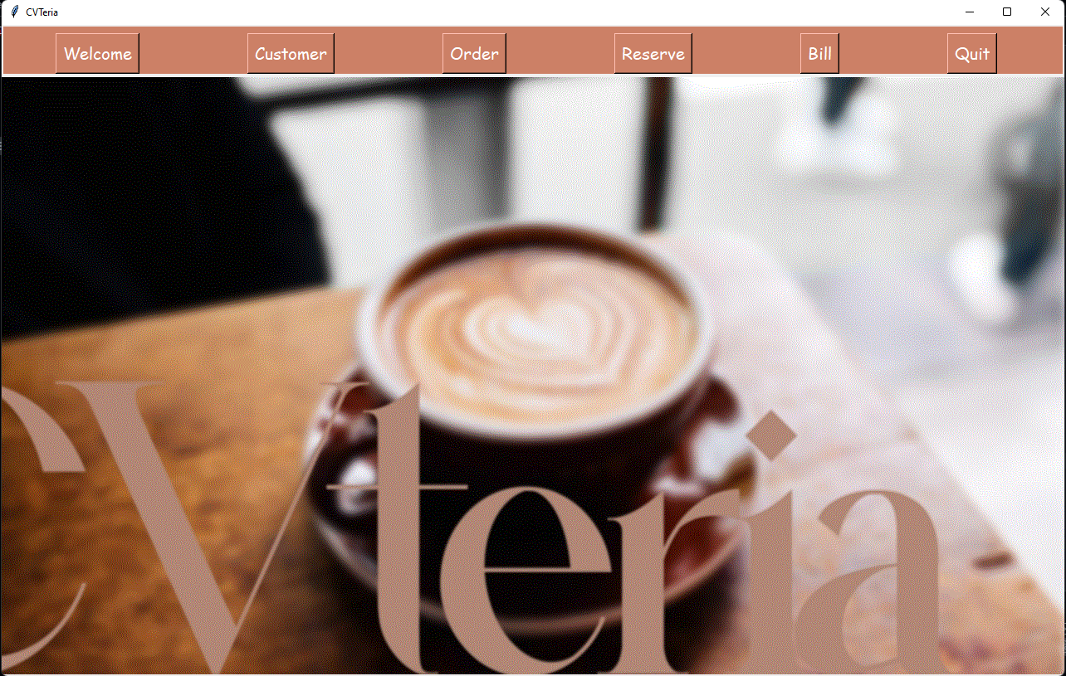

**Customer Listing Screen:**

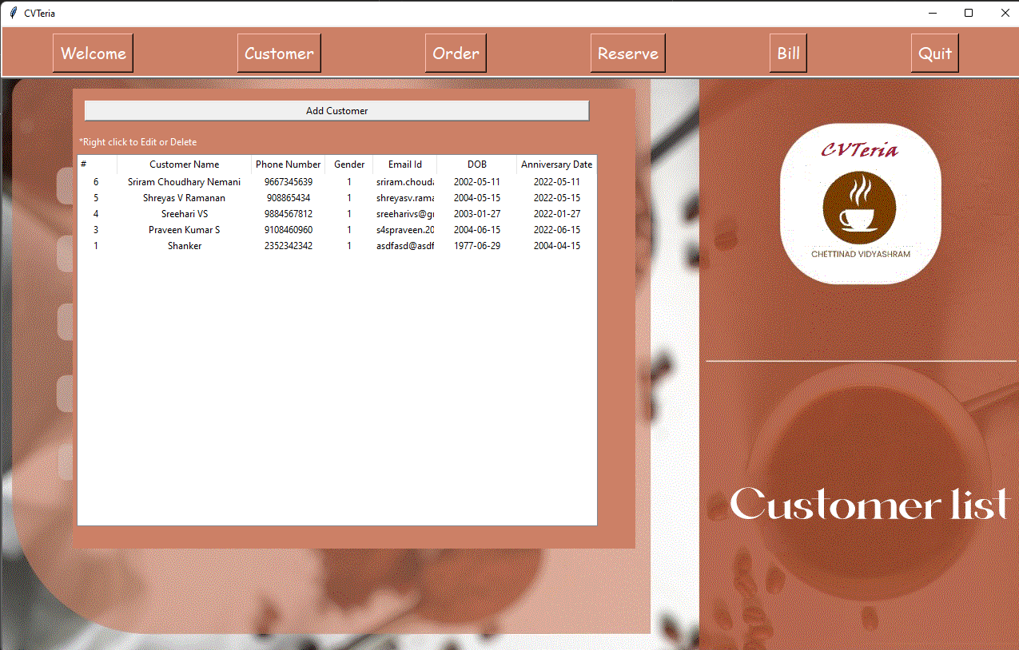

**Order Listing Screen:**

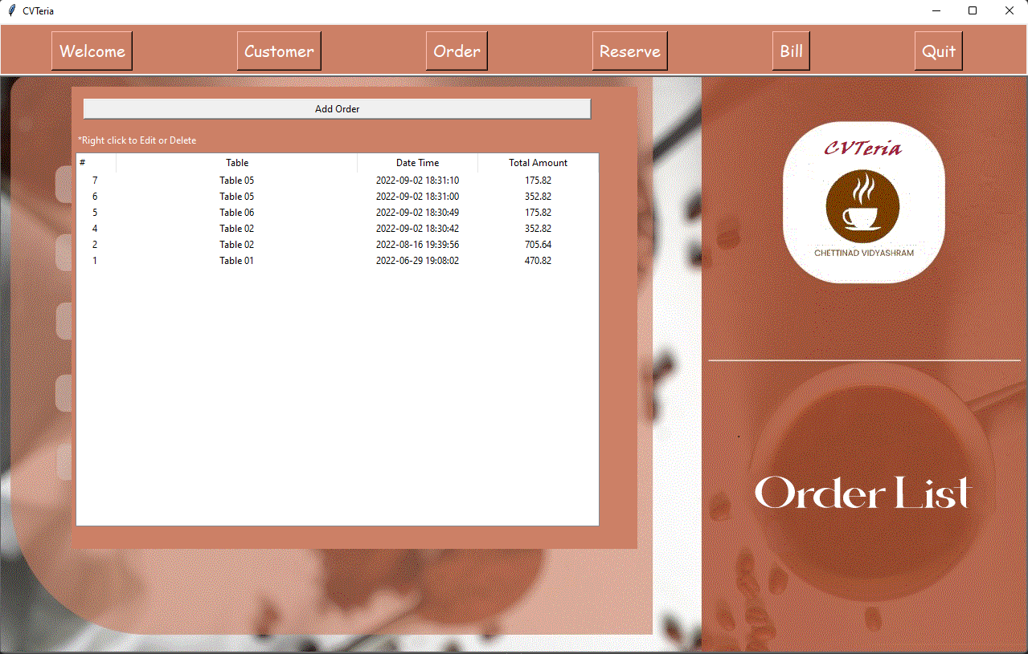

**Table Reservation Screen:**

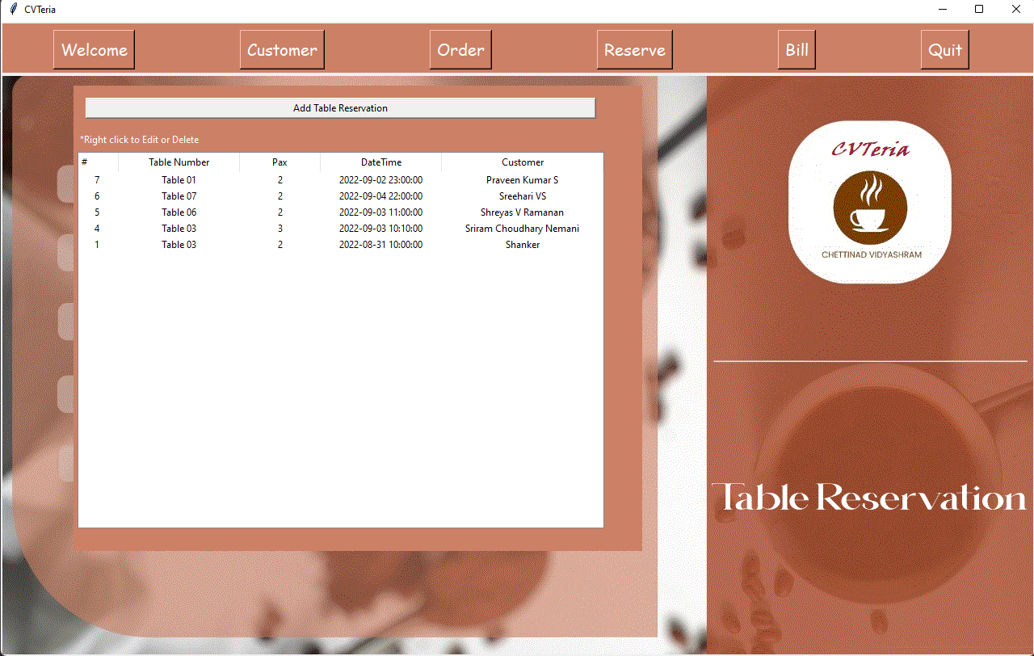

**Bill Listing Screen:**

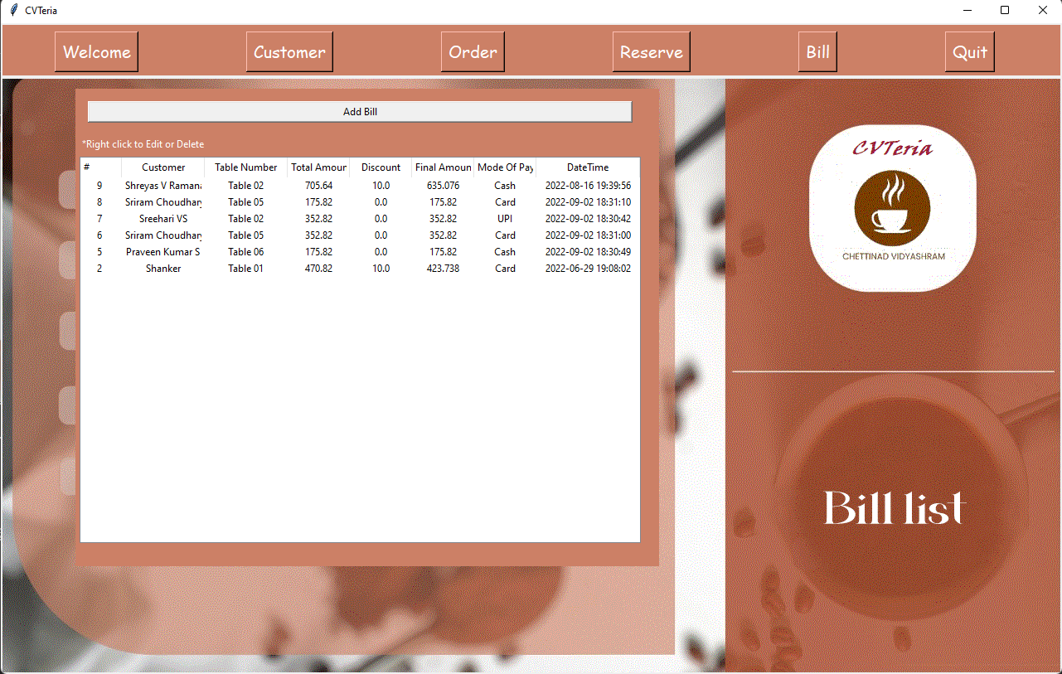

**Create Customer Screen:**

“Customer Created Successfully” message is displayed

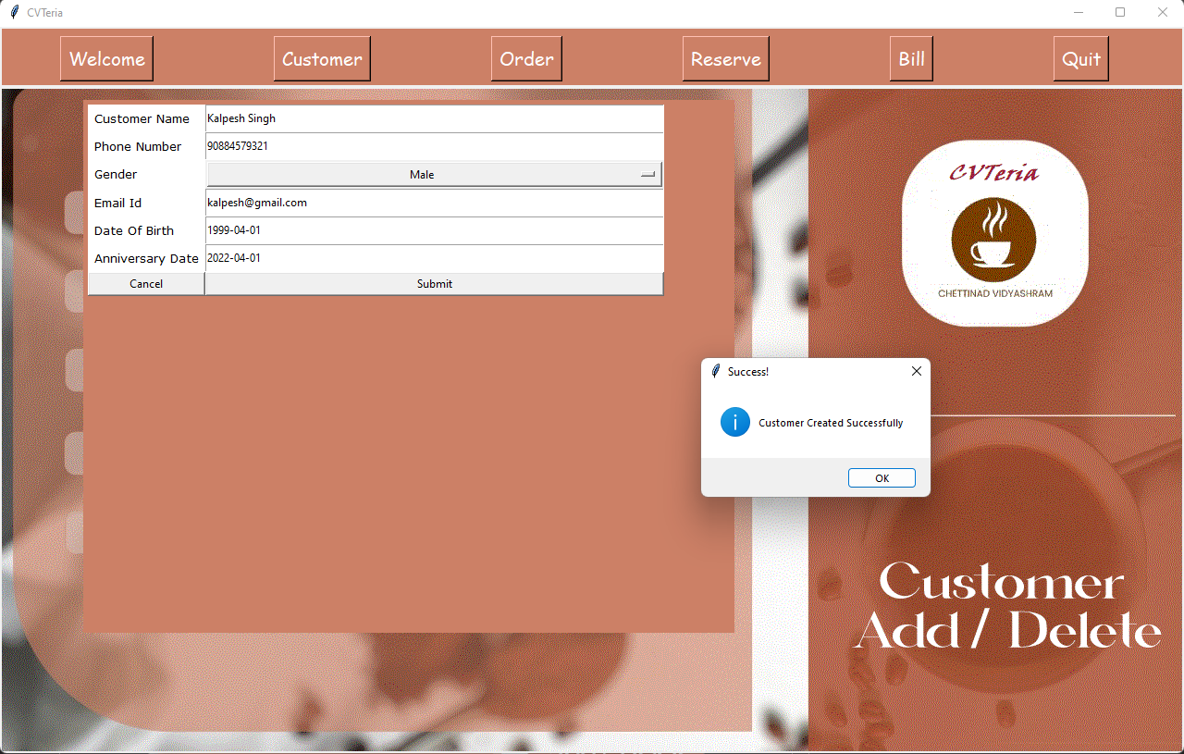

**Create Order Screen:**

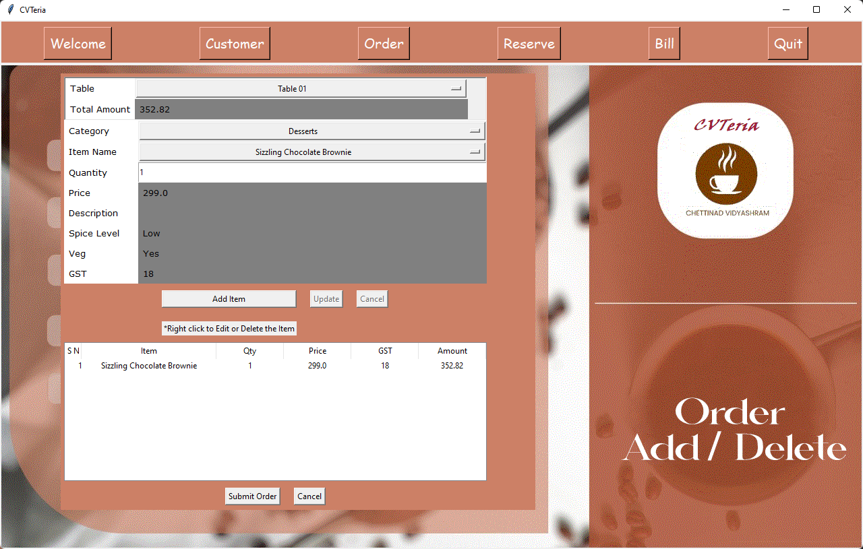

**Create Table Reservation Screen:**

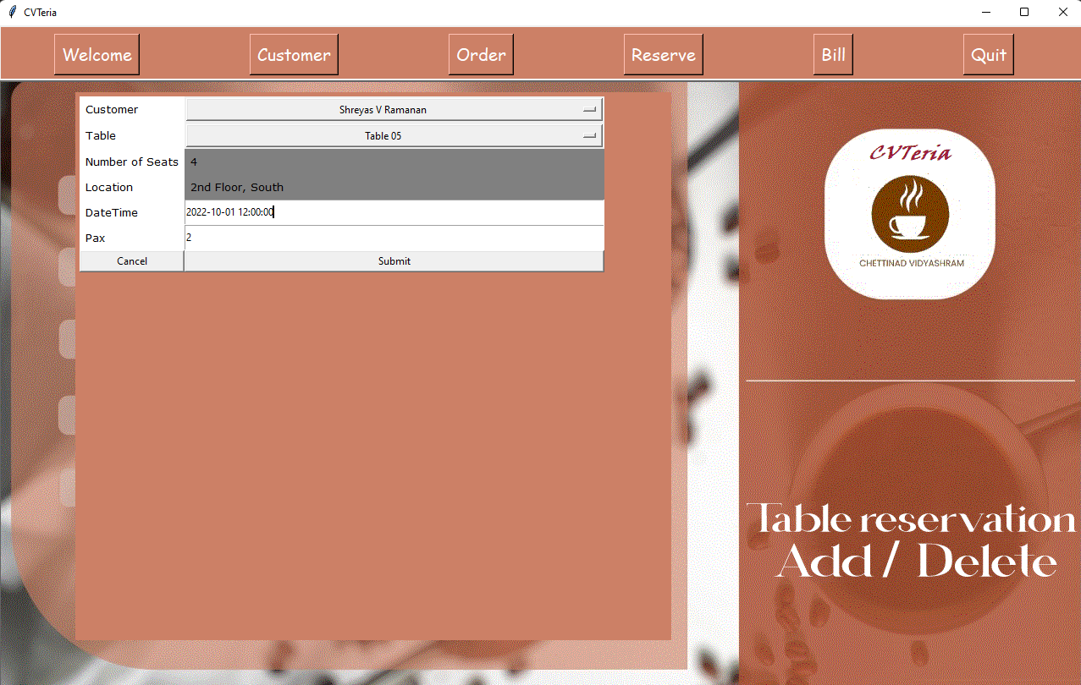

**Create Bill Screen:**

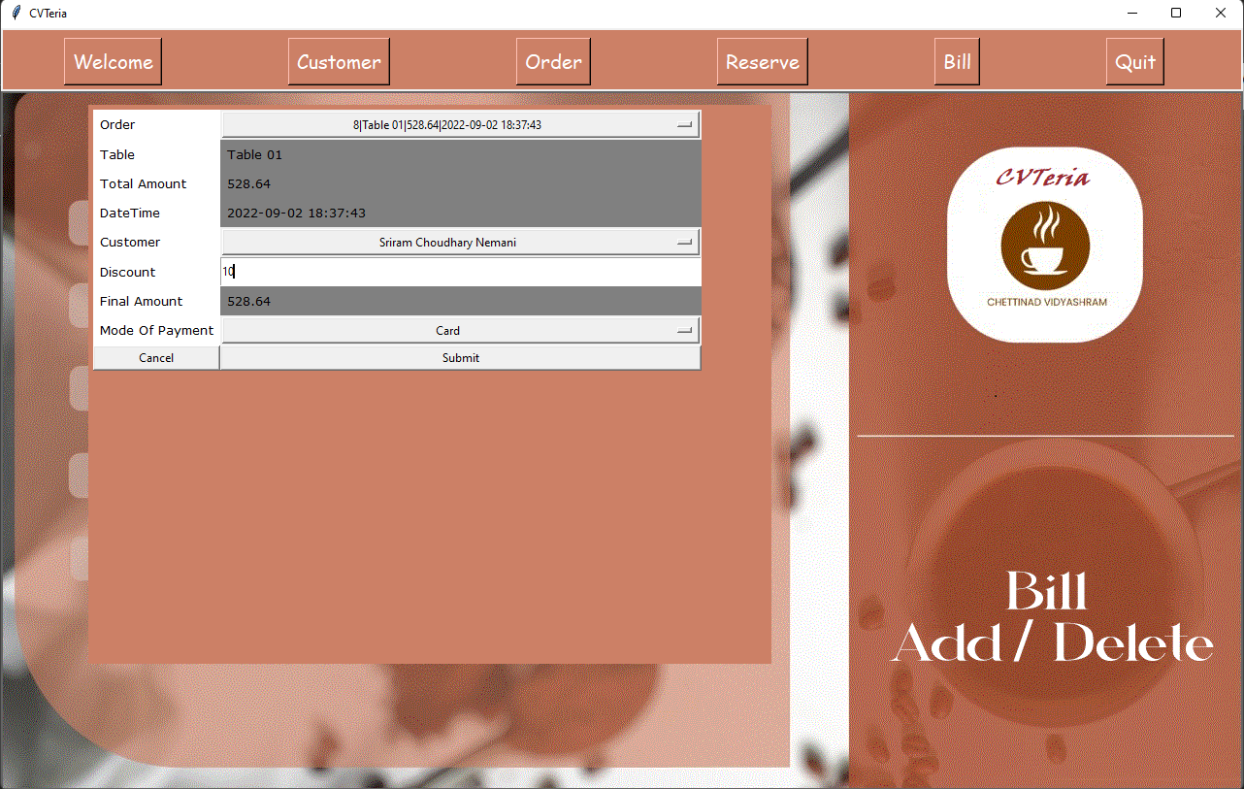

**Edit/Delete Customer (Enabled on right clicking):**

Customer Deleted successfully message is displayed

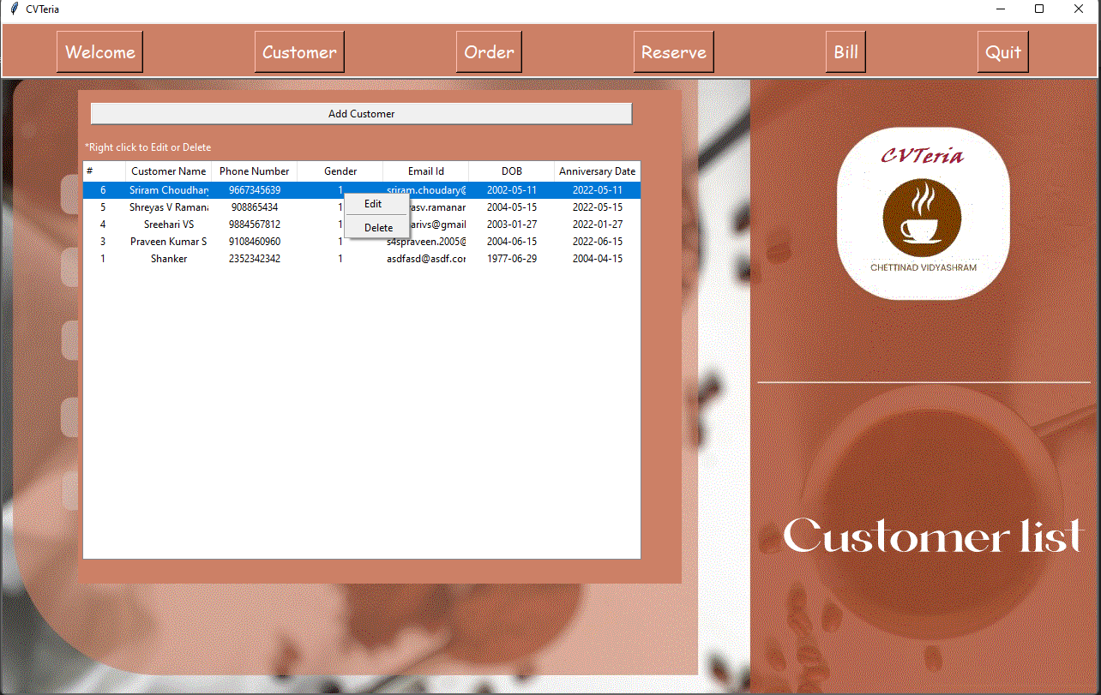

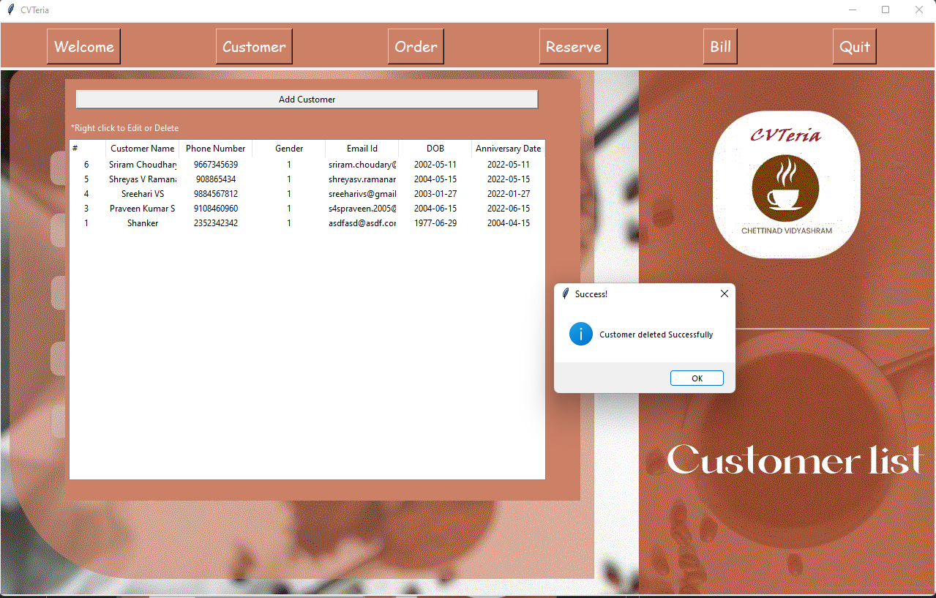

Note: Editing and Deleting and enable for all screens.

Message boxes are also enabled for every screen.

**Edit Specific Item in an order:**

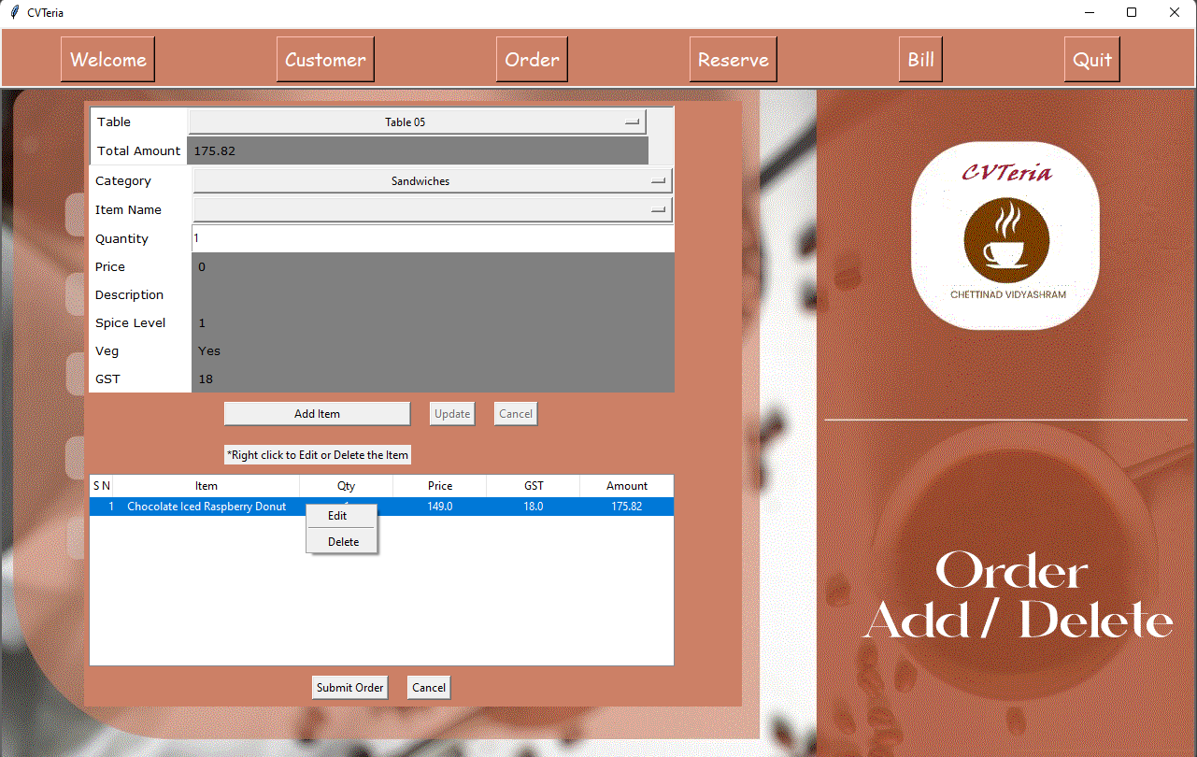

On Editing a specific item, the program only allows you to change the quantity and nothing else

The update button becomes active since we are only editing and not adding a new item…

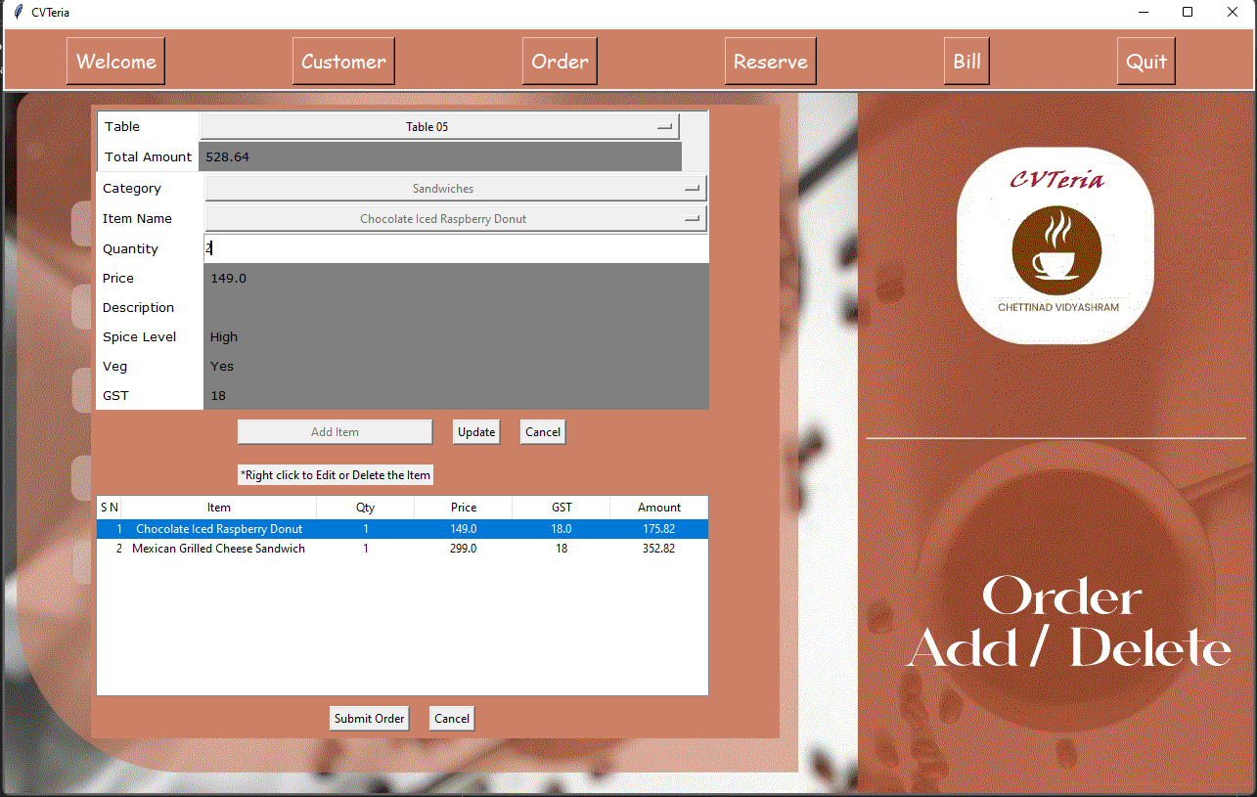

**Validation:**

The following validations have been enabled in Customer screen:

* 1. Phone Number: Phone number should be at least 5 digits long and it can’t be more than 15 digits long.



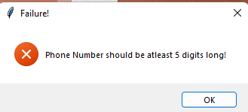 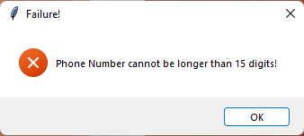



* 1. Email ID: Email ID should be of the form [abc@abc.com](mailto:abc@abc.com)

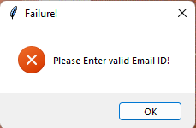



* 1. Date Validation: Minimum Age to create an account in our cafeteria is 18 years.

Difference between birth date and anniversary should be at least 18 years.

Date should be valid in YYYY-mm-dd format.

Anniversary date cannot be a future date.

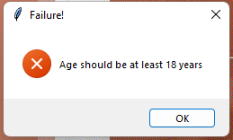

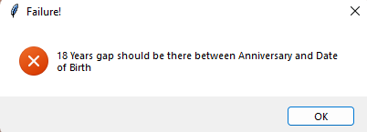

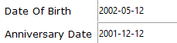

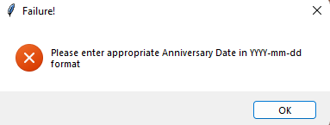



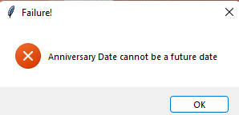



The following validations have been added in order screen:

1. Table Number: One cannot submit order without selecting table number.

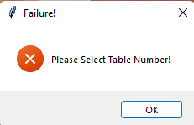



1. Items: The minimum number of items to be added for an order to be placed is 1. 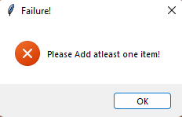

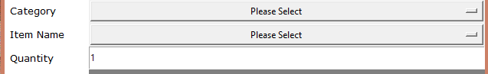

The following validations have been added to table reservation screen:

1. Customer: One cannot reserve a table without selecting which customer.

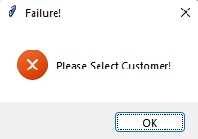



1. Table: One cannot reserve a table without selecting the table.

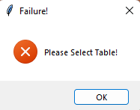



1. Date Time: Date and time should be entered in valid format. Date should be a future date and time.

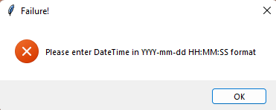



1. Number of People: The number of people the reservation is being made for should not exceed the number of seats at the table.

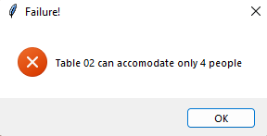

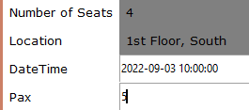

The following validations have been added to Bill screen:

1. Customer: To Create a bill, customer should be selected.



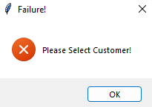

**CONCLUSION**

**Scope Of Improvement:**

The application can be improved by integrating with other Cafeteria Management applications and also further improvement can be made on the GUI with additional features. An online interface can be made available so that it can be accessed from PC and Mobile. The security of the system can further be improved by using other authorization solutions.

**BIBLIOGRAPHY**

1. Stackoverflow.com
2. W3schools.com
3. Javatpoint.com
4. Youtube.com